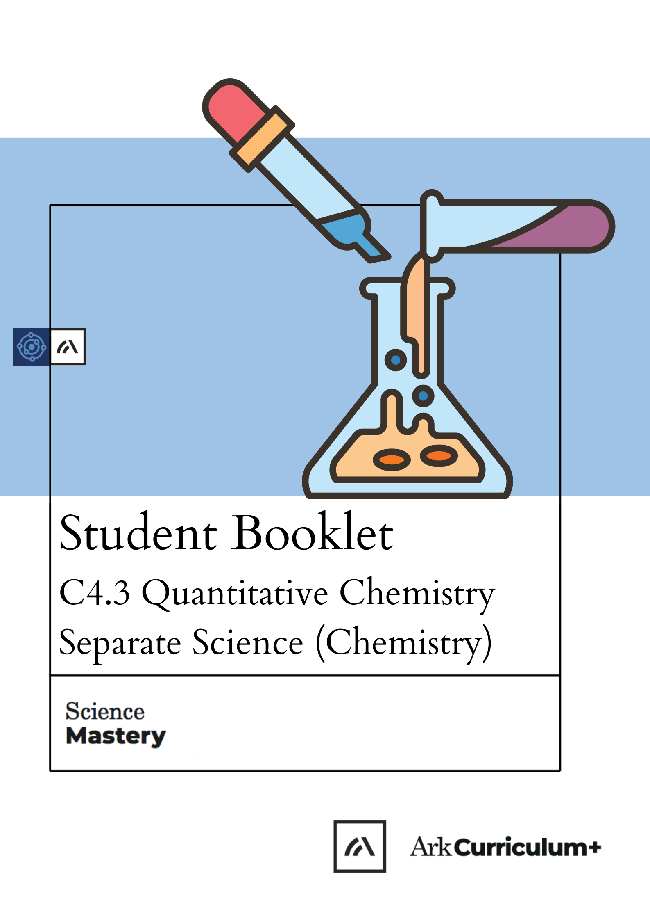


Quantitative Chemistry
The Big Idea

What does it mean to have an amount of a substance? How can I use information about different elements and compounds to predict the outcomes of reactions? How could we use this information in industrial processes to calculate how much of a reactant we need to make a certain amount of product?
Quantitative chemistry allows us to do calculations to find out about quantities of substances. This is a very important application of chemistry that is used in industry and research. Using the relative formula mass and number of moles of a substance we can look closely at the amount of reactants and productions in chemical reactions.
This is the fourth unit we are studying as part of the big idea: Reactions Rearrange Matter
In this unit, we will begin by recapping the ideas of relative atomic mass and relative formula mass, as well as how we can use relative formula mass to determine the percentage by mass of an element in a compound. We will then look at the concept of moles in chemistry and how we can use them in chemical equations to calculate reacting masses and limiting reactants.
We will also review the idea of concentration and learn how to calculate the concentration of different solutions. We will also look at acids, alkalis and neutralisation and the difference between strong and weak acids. Separate science students will also look at titrations of acids and alkalis and the volume of gases.
In this unit, we will revisit some key skills including balancing equations, calculating percentages and substituting into and solving equations.
TASKS:
What subject will this unit focus on? BIOLOGY CHEMISTRY PHYSICS
(circle the correct subject)
There are lots of keywords underlined above. List these into the two columns:
Words I know | Words I haven’t seen before

To answer before the unit:
- What are you most excited to learn about in this topic?
_____________________________________________________________________________________________________________________________________________________________________________________________

- What do you already know about this topic?
_____________________________________________________________________________________________________________________________________________________________________________________________

- Why do you think it’s important to learn how reactions rearrange matter?
_____________________________________________________________________________________________________________________________________________________________________________________________

- What knowledge from previous science lessons might help us?
_____________________________________________________________________________________________________________________________________________________________________________________________

- What questions do you have about this topic?
_____________________________________________________________________________________________________________________________________________________________________________________________

To answer at the end of the unit:
- Tick off any words in the ‘words I haven’t seen before’ column that you are now confident with. Circle any you still need more practice to use.
- What have you most enjoyed about this unit?
_____________________________________________________________________________________________________________________________________________________________________________________________

- What more would you like to learn about reactions as part of the big idea: ‘Reactions Rearrange Matter’?
______________________________________________________________________________________________________________________________

Pre-Test
- Below shows a chemical formula of a compound.
CaCO₃
Choose the correct number of atoms in one molecule. [1]
Tick ( ) one box.
- 1 calcium atom, 1 carbon atom, 3 oxygen atoms | 
- 1 calcium atom, 3 carbonate atoms
- 3 calcium atoms, 3 carbon atoms, 3 oxygen atoms

- Choose the correct state symbol for an aqueous solution. [1]
Tick ( ) one box.
- (l)
- (s)
- (aq)

- Below shows a symbol equation of a chemical reaction.
CaCO_{3(s)} à CaO_{(s)} + CO_{2(g)}
When this reaction was carried out in a beaker on a balance, the mass decreased.
Choose the best explanation for why. [1]
Tick ( ) one box.
- Carbon dioxide gas is produced which has no mass
- Carbon dioxide gas left the beaker
- Reactants always have a greater mass than the products formed
- Below shows an incomplete word equation for a chemical reaction.
Calcium carbonate + hydrochloric acid carbon dioxide + ________________ + water
Choose the missing substance. [1]
Tick ( ) one box.
- Chlorine carbonate
- Calcium chloride
- Hydrocarbonate
- 200 g sodium hydroxide was dissolved in water to make 1 dm³ solution.
Choose the concentration of this sodium hydroxide solution. [1]
Tick ( ) one box.
- 0.2 g/dm³
- 0.005 g/dm³
- 200 g/dm³

- Choose the relative formula mass of CO_{2.}
(Ar: C = 12; O = 16) [1]
- M_{r} = 44
- M_{r} = 28
- M_{r} = 56

- Choose the most appropriate equipment for accurately measuring 10 cm³ water. [1]
Tick ( ) one box.
- 10 cm³ measuring cylinder
- 10 cm³ beaker
- 10 cm³ evaporating dish

- A student investigated how heating calcium carbonate affected its mass.
Calcium carbonate was heated in a test tube for 1 minute.
The mass was measured before and after heating, then the change in mass recorded.
This was repeated four times and the results are shown below.

Repeat number | Change in mass (g)
1 | 12
2 | 13
3 | 10
4 | 9

Choose the correct analysis of these results. [1]
Tick ( ) one box.
- The change of mass of 9 g is an anomaly
- The change in mass is 11 g +/- 2 g
- The results are very precise

- Choose the technique that would separate insoluble copper carbonate from a copper sulfate solution. [1]
Tick ( ) one box.
- Filtration
- Evaporation
- Crystallisation

- Choose the correct hazard for using dilute hydrochloric acid. [1]
Tick ( ) one box.
- It is an irritant and could irritate skin
- Wear safety goggles so acid cannot get into eyes
- It is quite likely that the acid splashes onto skin and it must be rinsed off immediately

- Convert 12 dm³ to cm³. [1]
Tick ( ) one box.
- 1200 cm³
- 0.012 cm³
- 12000 cm³

- Choose the relative formula mass of (NH₄)₃PO_{4.}
(Ar: N = 14; H = 1; P = 31; O = 16) [1]
Tick ( ) one box.
- M_{r} = 123
- M_{r} = 121
- M_{r} = 149
- M_{r} = 144

- 300 g of H₂SO₄ is dissolved in water to make 500 cm³ of solution.

Choose the concentration of this solution. [1]
Tick ( ) one box.
- 600 g/cm³
- 0.6 g/cm³
- 1.66 g/cm³

- Choose the correct compounds that react to make copper sulfate crystals. [1]
Tick ( ) one box.
- Copper and sulfate
- Copper oxide and sulfuric acid
- Copper sulfide and oxygen

- Choose which of the symbol equations below is balanced. [1]
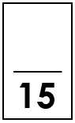
Tick ( ) one box.
- N₂ + H₂ NH₃
- 3 N₂ + 3 H₂ NH₃
- N₂ + 3 H₂ 2 NH₃

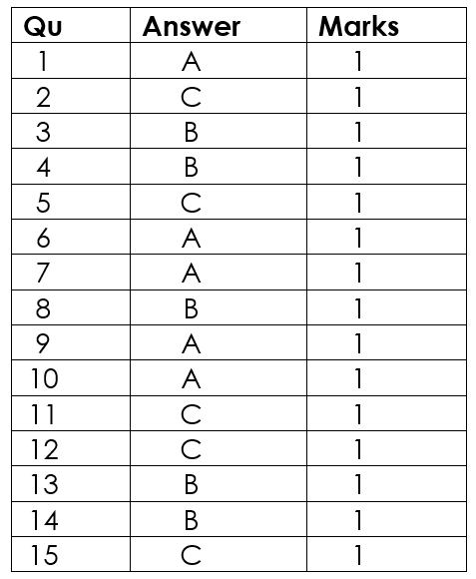

End of Unit Pre-Test. Turn over to see the answers. Give yourself a mark out of 10.

Relative Formula Mass
Knowledge Organiser
- Formulae show which elements are in compounds and the ratio of each element in the compound.
For example:
CaCO₃ contains one calcium atom, one carbon atom and 3 oxygen atoms
- Chemical reactions always involve the formation of one or more new substances
- The relative atomic mass of an element can be found as the mass number of an element on the periodic table
- Relative atomic mass has the symbol A_{r}
- The relative formula mass of a compound is the sum of the relative atomic masses of the atoms in the numbers shown in the formula
- Relative formula mass has the symbol M_{r}
- For example, the M_{r} of CaCO3 is 40+12+(16x3) = 100
- In a balanced chemical equation, the sum of the relative formula masses of the reactants in the quantities shown equals the sum of the relative formula masses of the products in the quantities shown
- The percentage by mass of an element in a compound can be calculated using the relative atomic mass and the relative formula mass, using the formula:

$$\% by mass =\frac{mass of element}{mass of compound} × 100$$
The Mole (HT only)
- Chemical amounts are measured in moles
- The symbol for the unit mole is mol
- The mass of one mole of a substance in grams is numerically equal to its relative formula mass
- One mole of a substance contains the same number of the stated particles, atoms, molecules or ions as one mole of any other substance
- One mole of a substance contains 6.02 x 10²³ particles
- This number is the Avogadro constant or Avogadro’s number
- The measurement of amounts in moles can apply to atoms, molecules, ions, electrons, formulae and equations
- The mass of a substance can be calculated from the number of moles, using the relative formula mass:
$$number of moles = \frac{mass}{Mr}$$
- This equation can also be written as:
$$mass = number of moles × Mr$$

- The masses of reactants and products can be calculated from balanced symbol equations
- Chemical equations can be interpreted in terms of moles. For example:
Mg + 2HCI MgCI₂ + H₂
shows that one mole of magnesium reacts with two moles of hydrochloric acid to produce one mole of magnesium chloride and one mole of hydrogen gas.
- The coefficients show the molar ratio in which reactants react and products are made which can be used to calculate the mass of a reactant or product
- The balancing numbers in a symbol equation can be calculated from the masses of reactants and products by converting the masses in grams to amounts in moles and converting the numbers of moles to simple whole number ratios.
- A reaction finishes when one of the reactant is all used up. The other reactant has nothing left to react with, so some of it is left over
- The reactant that is completely used up is called the limiting reactant because it limits the amount of products
- The reactant that is left over is described as being in excess
- In a chemical reaction involving two reactants, it is common to use an excess of one of the reactants to ensure that all of the other reactant is used
- The mass of a product formed in a reaction depends upon the mass of the limiting reactant
- The maximum mass of a product formed in a reaction can be calculated using the balanced equation, the mass of the limiting reactant and the relative formula mass of the limiting reactant and the product

Acids, Alkalis and Neutralisation
- Acids are neutralised by alkalis (e.g. soluble metal hydroxides) and bases (e.g. insoluble metal hydroxides and metal oxides) to produce salts and water, and by metal carbonates to produce salts, water and carbon dioxide.
- The particular salt produced in any reaction between an acid and a base or alkali depends on:
- the acid used (hydrochloric acid produces chlorides, nitric acid produces nitrates, sulfuric acid produces sulfates)
- the positive ions in the base, alkali or carbonate.
- Acids also react with metals to produce a salt and hydrogen gas This is not a neutralisation reaction
- Acids produce hydrogen ions (H⁺) in aqueous solutions
- Aqueous solutions of alkalis contain hydroxide ions (OH–)
- The pH scale, from 0 to 14, is a measure of the acidity or alkalinity of a solution, and can be measured using universal indicator or a pH probe
- A solution with pH 7 is neutral. Aqueous solutions of acids have pH values of less than 7 and aqueous solutions of alkalis have pH values greater than 7
- In neutralisation reactions between an acid and an alkali, hydrogen ions react with hydroxide ions to produce water
- A neutralisation reaction can be represented by the equation H⁺(aq) +OH⁻(aq) H₂O(l)

Strong and Weak Acids (HT only)
- A strong acid is completely ionised in aqueous solution. This means that the acid splits up into its ions. Another word for ionised is dissociated.
- Examples of strong acids are hydrochloric, nitric and sulfuric acids.
- A weak acid is only partially ionised in aqueous solution.
- Examples of weak acids are ethanoic, citric and carbonic acids.
- The higher the concentration of H⁺ ions in a solution, the lower the pH
- The higher the concentration of OH⁻ ions in an alkaline solution, the higher the pH
- For a given concentration of aqueous solutions, the stronger an acid, the lower the pH
- As the pH decreases by one unit, the hydrogen ion concentration of the solution increases by a factor of 10
- In a dilute acid, the acid molecules are mixed with a large volume of water, so there is a low concentration of H⁺ ions
- In a concentrated acid, few or no water molecules are mixed with the acid molecules. This means the concentration of H⁺ ions is high.

Concentration
- Many chemical reactions take place in solutions
- The concentration of a solution tells you how much solute is dissolved in a given volume of solution
- Concentration can be defined as the mass of solute per unit volume of solvent.
- Volume means the amount of space that a substance takes up, and can be measured in cm³, dm³, m³, L or mL.
- 1 dm³ is equal to 1 L and equal to 1000 cm³
- To convert from dm³ to cm³ the number should be multiplied by 1000
- To convert from cm³ to dm³ the number should be divided by 1000
- The concentration of a solution can be measured in mass per given volume of solution, e.g., grams per dm³ (g/dm³)
- The mass in grams of solute in a given volume of solution can be calculated from its concentration in g/dm³
- The equation that links concentration, mass of solute and volume is:
$$Concentration = \frac{mass}{volume}$$
Concentration (Chemistry only)
- The concentration of a solution can be measured in mol/dm³
- The amount in moles of solute or the mass in grams of solute in a given volume of solution can be calculated from its concentration in mol/dm³
- The equation that links concentration, amount of substance and volume is:
$$Concentration = \frac{number of moles}{volume}$$
- The concentration of a solution in mol/dm³ is related to the mass of the solute and the volume of the solution
- If the volumes of two solutions that react completely are known and the concentration of one solution is known, the concentration of the other solution can be calculated

Titration (Chemistry only)
- The volumes or concentrations of acid and alkali solutions that react with each other can be measured by titration using a suitable indicator
- A titration is an example of quantitative analysis
- A pipette is used to accurately measure a certain volume of acid or alkali
- A pipette filler is used to fill the pipette safely
- A conical flask is used to contain the liquid from the pipette
- A burette is used to add small, measured volumes of one reactant to the other reactant in the conical flask
- Before starting the titration, the burette should be rinsed with the solution it is going to contain and clamped vertically. Once filled the tap should be flushed to remove any air bubbles
- Only a few drops of indicator should be added to conical flask. This is because many indicators are weak acids or alkalis, and too much would affect the outcome of the titration
- The indicator shows by a colour change when all of the alkali in the conical flask has been neutralised. This is called the end point
- A white tile is placed under the conical flask so that any colour change can be seen clearly
- An appropriate indicator to use for an acid-alkali titration is phenolphthalein.
- Phenolphthalein is pink in alkaline solutions and colourless in acidic solutions
- The difference between the burette reading at the start and the reading at the end of the titration gives the volume of acid (or alkali) added.
- This volume is called a titre.
- The first titre is usually ignored, as it is a rough result.
- Results that are within 0.2 cm³ of each other are called concordant results.
- Multiple titrations are usually carried out, and an average (mean) titre is calculated for any that are within 0.2 cm³ of each other.

Volumes of Gases (Chemistry only)
- Equal amounts in moles of gases occupy the same volume under the same conditions of temperature and pressure.
- Room temperature is 20 ºC
- Room pressure is 1 atmosphere
- Rtp' means 'at room temperature and pressure'
- The volume of one mole of any gas at room temperature and pressure is 24 dm³
- This volume (24 dm³) is called the molar volume of a gas
- The volume of gas at rtp can be calculate using the equation:

$$Volume=number of moles × 24$$

- The volumes of gaseous reactants and products can be calculated from the balanced equation for the reaction.
- The volume of a gas at room temperature and pressure can be calculated from its mass and relative formula mass

Glossary
Acid | A substance that produces H⁺ ions in aqueous solutions.  Acids can be neutralised by alkalis.
Alkali | A substance that produces OH⁻ ions in aqueous solutions.  An alkali is a soluble base.
Aqueous solution | A solution in which the solvent is water.  Many chemical reactions take place in aqueous solutions.
A_{r} | This is the symbol for relative atomic mass.  See relative atomic mass.
Avogadro’s number | The constant or number that shows how many particles, molecules, atoms, or ions there are in 1 mole of a substance.  Avogadro’s number is 6.02 x10²³.
Burette | A piece of equipment used to measure a variable volume in a titration.  A burette is used to add one solution dropwise to another.
Chemical formula | A series of chemical symbols showing the number of atoms of each element in a compound.  The chemical formula for Magnesium Oxide is MgO.
Coefficient | The ‘big’ number or balancing numbers in front of a chemical formula in an equation.  In the equation 2Mg + O₂ 2MgO, the coefficient in front of magnesium is 2.
Compound | A substance made up of two or more different elements chemically bonded together.  Water is a compound of hydrogen and oxygen.
Concentration | The mass of solute dissolved in a given volume of solvent  The concentration of the copper sulphate solution was 0.1 g/cm³
Concentrated | If a solution is concentrated, there is a large mass of solute in a given volume of solvent.  The salt water solution was concentrated because lots of salt was added to a small volume of water.
Concordant | Results that fall within 0.2 cm³ of each other.  When doing a titration, only the concordant results should be used to calculate the mean titre.
Conservation of Mass | The law of conservation of mass states that the total mass of reactants in any chemical reaction equals the total mass of products  5 g of iron and sulfur reacted together to make 5 g of iron sulfide. This demonstrates the Law of Conservation of Mass.
Dilute | To decrease the concentration of a liquid by mixing it with water or another liquid.  I plan to dilute the acid by adding more water.
Dissociate | When an acid or alkali splits into its ions in solution.  Hydrochloric acid dissociates in solution:  HCl (aq) H⁺ (aq) + Cl⁻ (aq).
Element | A substance made of only one type of atom.  Oxygen is an example of an element.
Excess | The reactant that is not used up in a reaction, so some is left over.  When magnesium burns in excess oxygen, the magnesium is used up but the oxygen is not.
Formulae | Plural of formula  See chemical formula
Ionise | Another way to describe dissociation, or the formation of ions. When an acid or alkali splits into its ions in solution.  Hydrochloric acid ionises in solution:  HCl (aq) H⁺ (aq) + Cl⁻ (aq).
Limiting reactant | The reactant that is used up in a reaction, so limits the amount of product that can be made.  When magnesium burns in excess oxygen, the magnesium is the limiting reactant.
Mass | The amount of matter in a substance.  In physics, we measure mass in kg but in chemistry we often use smaller masses, so we can measure mass in g instead.
Molar ratio | The ratio of balancing numbers in front of the chemical formulae in an equation, showing the ratio in which reactants react and products are made.  In the equation 2Mg + O₂ 2MgO, the molar ratio of magnesium to oxygen is 2:1.
Molar volume | The volume of one mole of any gas at room temperature and pressure.  Molar volume at rtp is 24 dm³.
Mole | The amount of substance that contains 6.02 x10²³ particles.  1 mole of carbon dioxide contains the same number of molecules as 1 mole of oxygen or 1 mole of ammonia.
Molecule | A small group of non-metal atoms chemically bonded together.  Oxygen gas is made up of many oxygen molecules, each with the chemical formula O₂.
M_{r} | This is the symbol for relative formula mass.  See relative formula mass.
Neutralisation | A chemical reaction in which an acid and a base react with each other.  Neutralisation reactions produce a salt and water.
pH | A measure of the acidity or alkalinity of a solution.  Acids have a pH of less than 7.
pH probe | An instrument used to measure the pH of a solution.  A pH probe can give a numerical value for pH whereas universal indicator gives a colour that corresponds to a number on the pH scale.
Phenolphthalein | An indicator often used in titrations because of its clear colour change.  Phenolphthalein is pink in alkaline solutions but turns colourless in acidic solutions.
Pipette | A piece of equipment used to measure a fixed volume accurately.  A pipette allows a more precise volume of liquid to be measured than a measuring cylinder.
Product | The substance(s) that are made in a chemical reaction.  In the equation 2Mg + O₂ 2MgO, magnesium oxide is the product.
Reactant | The substance(s) that react in a chemical reaction to form a new substance.  In the equation 2Mg + O₂ 2MgO, magnesium and oxygen are the reactants.
Relative atomic mass | The relative atomic mass of an element is the average mass of its atoms compared to the mass of a carbon-12 atom. The relative atomic masses for each element are given in the Periodic Table.  The relative atomic mass of oxygen is 16.
Relative formula mass | The relative formula mass of a substance is the sum of the relative atomic masses of its atoms, in the numbers shown in its chemical formula.  The relative formula mass of a molecule of H₂O is 18.
RTP | Room temperature and pressure: 20 ºC and 1atm of pressure.  Molar volume at rtp is 24 dm³.
Solute | A substance that is dissolved in a solvent.  Salt is the solute when it is dissolved in water.
Soluble | A substance is soluble if it can be dissolved in a solvent  Sugar is soluble in water.
Solution | A mixture of a dissolved solute and a solvent.  A solution of salt and water was used.
Solvent | A substance in which a solute can dissolve  Water is a solvent because salt can dissolve in it
Strong | (Of an acid) An acid that fully dissociates in solution.  Hydrochloric acid is an example of a strong acid.
Subscript | The numbers that come after and below a chemical symbol in a chemical formula, to indicate the number of atoms of that element.  The subscript number two shown in a molecule of CO₂ indicates that it contains 2 atoms of oxygen.
Titration | A method of quantitative analysis used to determine the volume of acid/alkali needed to completely neutralise an alkali/acid.  A titration can be used to measure the volume of hydrochloric acid needed to neutralise 25 cm³ of sodium hydroxide.
Titre | The volume of acid/alkali needed to completely neutralise the alkali/acid in a titration.  The titre can be calculated using the starting and final volume readings on a burette.
Universal Indicator | A solution that changes colour depending on the pH of the solution it is added to.  Universal indicator turns green when it is added to a neutral solution.
Volume | The amount of space a substance takes up.  In chemistry, volume is measured in dm³.
Weak | (Of an acid) An acid that partially dissociates in solution.  Ethanoic acid is an example of a weak acid.
Do Now
Prior Knowledge Review: Relative Formula Mass and Percentage by Mass

- State the chemical symbol for nitrogen.
- State how many atoms of each different element are present in CaCO₃.
- State where metals are found on the periodic table.
- Explain the difference between an element and a compound.
- State the mass number of oxygen.
Drill:
- Calculate 65% of 120.
- A sample is made up of 40 g of water and 12 g of sugar. Calculate the percentage of the sample that is sugar.
- Write the chemical symbol for potassium.

Read Now:
The relative atomic mass of an element is the average mass of the atoms in the element compared to the mass of carbon-12. This means that relative atomic mass takes into account the mass of different isotopes of an element and how much of each isotope exists. The relative formula mass is the sum of the relative atomic masses of the elements in a compound. This is calculated using the relative atomic mass of each element present and how many of each atom are present in an element or compound. The relative atomic mass is taken from the mass number on the periodic table. The relative atomic mass of hydrogen is 1 and the relative atomic mass of oxygen is 16. Water has the formula H₂O, so its relative formula mass is 18 because it has two hydrogen atoms and one oxygen atom.
- Define relative atomic mass.
- Explain what is meant by isotopes.
- Define relative formula mass.
- State the relative formula mass of water.
- Explain where this number comes from.

Relative Atomic Mass
What does relative mean?

Define relative atomic mass (RAM/Ar)

State the relative atomic mass (A_{r}) for the following elements.
- Potassium
- Iron
- Neon
- Hydrogen
- Gold
- Sulfur
- Helium
- Magnesium
- Carbon

Relative Formula Mass
Define relative formula mass (RFM/Mr)

Calculate the relative formula mass of Magnesium nitrate, Mg(NO₃)₂ using the table
Element | Ar | Number of atoms | Total mass
Mg
N
O
Total mass (Mr)

Calculate the M_{r} for the following compounds.
(A_{r}: H = 1; C = 12; N = 14; O = 16; K = 39)
  - NH₃
  - O₂
  - H₂O
  - KOH
Use your understanding of the conservation of mass to find the M_{r} of CaO. (M_{r}: CaCO₃ = 100; CO₂ = 44)
CaCO₃ CaO + CO₂
Percentage by mass
What is the formula for percentage by mass?
$\% by mass= \frac{\begin{aligned} \\ \end{aligned}}{ }$ x 100

What is the percentage by mass of carbon in CO₂?
- A. $\frac{12}{16}$ X 100 = 75%
- B. $\frac{24}{32}$ X100 = 75%
- C. $\frac{12}{32}$ X100 = 37.5 %
- D. $\frac{12}{44}$ X 100 = 27.3%
Drill

- Define relative atomic mass.
- State the relative atomic mass of carbon.
- State the relative atomic mass of oxygen.
- Define relative formula mass.
- Calculate the relative formula mass of CO₂.
- Calculate the relative formula mass of KOH.
- State the equation to calculate percentage by mass.
- Calculate the percentage by mass of potassium in potassium hydroxide (KOH).
- Calculate the percentage by mass of chlorine in calcium chloride (CaCl₂).

Exit Ticket
- Choose the correct definition of relative formula mass.
- A. The average mass of atoms of an element compared to the mass of arbon-12
- B. The sum of relative atomic masses in a compound
- C. The percentage of a compound is made of a particular element

- Calculate the relative formula mass of carbon dioxide (CO₂).
C = 12, O = 16
- A. 28
- B. 44
- C. 56

- Calculate the percentage by mass of oxygen in carbon dioxide.
- A. 27.27%
- B. 36.36%
- C. 72.72 %

Do Now
Introducing the Mole (HT only)

- Define relative atomic mass.
- Define relative formula mass.
- Calculate the Mr of ammonia (NH₃). N=14, H=1
- Calculate the Mr of calcium hydroxide (Ca(OH)₂). Ca=40, O=16, H=1
- Calculate the percentage by mass of hydrogen in ammonia.

Drill:
- Write 58230000 in standard form.
- Convert 3.07 x10⁴ from standard form.
- Write 0.0006 in standard form.

Read Now:
In chemical reactions, there are a huge number (think many, many trillions!) of atoms in reactants that rearrange to form the products. Remember in a chemical reaction, mass is conserved, so no atoms are made or lost during a chemical reaction, only rearranged. So that scientists can keep track of the numbers of atoms involved in different substances without having to write out huge numbers, scientists use a quantity called ‘the mole’. As with many things in chemistry, we use carbon as the reference. 12 g of carbon contains 6.02 x10²³ atoms. This number of atoms is called Avogadro’s number and is the number of atoms in one mole. As a definition, we can say that a mole is the number of atoms contained in 12 g of carbon.

- State the law of conservation of mass.
- State Avogadro’s number.
- Define a mole.
- State the relative atomic mass of carbon.

Introducing the mole
Symbol | Cu | S
A_{r} | 64 | 32

What would the ratio of the masses of these atoms be?
Is it possible to weigh one atom in our lab?
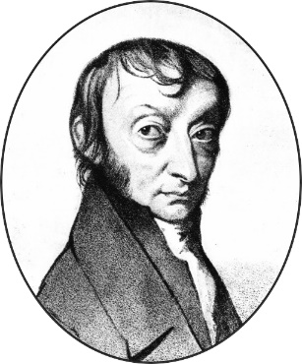
How should all standard form numbers look?

Which of these numbers is correct? Why?
2.38 x 10¹⁰ ^{or} ^{23.8 x 109}

Which value is avogadro’s number?

What do we call this value as a unit?

Decimal | Standard Form (Scientific Notation)
67,000,000,000
40,000,000,000,000,000
4,300,000
65,430,000
0.00000000004
0.0000000654
0.002
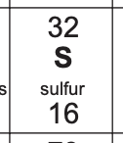
The relative formula mass of sulfur is 32.

How many atoms would there be in 32 g of sulfur?
How many moles are there in 32 g of sulfur?
How many atoms would there be in 64 g of sulfur?
How many moles would there be in 64 g of sulfur?

True or false?
- One mole of carbon contains the same number of atoms as one mole of copper.
- 1 gram of carbon contains the same number of atoms as 1 gram of copper.
- Atoms are very small.
- 6 g of carbon contains the same number of atoms as 29 g of copper.
- The symbol for the unit mole is mol.
- 1 mole of carbon contains 6.02 x 10²³ atoms.
- The number of atoms present in an object are very small.
- 12 g of carbon contain the same number of atoms as 63.5 g of copper.

Drill

- State the relative atomic mass of carbon.
- State Avogadro’s number.
- State how many atoms would be in 12 g of carbon.
- State how many moles would be in 12 g of carbon.
- State the relative atomic mass of calcium.
- State how many atoms would be in 40 g of calcium.
- State how many moles would be in 40 g of calcium.

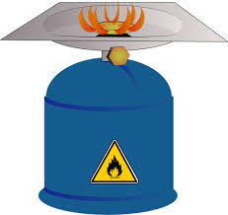
We: Moles and atoms
One mole of any substance contains 6.02 x 10²³ atoms or molecules of that substance.
Methane has the chemical formula CH₄.
What is the relative formula mass of methane?

What mass in grams would contain 6.02 x 10²³ molecules of methane?
What mass in grams would contain one mole of methane?
Stretch: what mass in grams would contain two moles of methane?

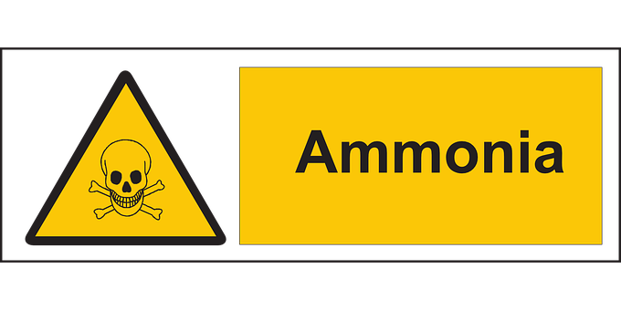
You: Moles, molecules and atoms
One mole of any substance contains 6.02 x 10²³ atoms or molecules of that substance.
Ammonia has the chemical formula NH₃.
What is the relative formula mass of ammonia?

What mass in grams would contain 6.02 x 10²³ molecules of ammonia?
What mass in grams would contain one mole of ammonia?
Stretch: what mass in grams would contain two moles of methane?
Stretch: how many atoms are there in one mole of ammonia?

Exit Ticket
- Which of the following is true?
  - A. The symbol for mole is mol.
  - B. The symbol for mole is moles.
  - C. The symbol for moles is m.

- How many molecules in 1 mole of CO₂?
  - A. 44
  - B. 6.02 x10²³
  - C. 1

- Which number is the same as 6 x 10³?
  - A. 60300
  - B. 63000
  - C. 6000

Do Now
Mole Calculations (HT only)

- State the relative atomic mass of boron.
- State how many particles are in one mole of a substance.
- State the mass in grams of boron that would contain this many particles.
- Calculate the M_{r} of copper carbonate (CuCO₃). Cu=63.5, C=12, O= 16
- Calculate the percentage by mass of oxygen in copper carbonate.

Drill:
- State Avogadro’s number.
- Calculate 3 x 4.83 x10¹¹. Write your answer in standard form.
- Calculate 0.25 x 4.83 x10¹¹. Write your answer in standard form.

Read Now:
In one mole of any substance there are 6.02 x10²³ particles. This can be atoms, molecules or ions. For example, one mole of water contains 6.02 x10²³ molecules of water and one mole of potassium contains 6.02 x10²³ atoms of potassium. The relative atomic mass of an element tells you the mass of that element (in grams) that contains exactly this number of atoms. The relative atomic mass of Neon is 20, so 20 g of Neon contains one mole (6.02 x10²³ atoms). The relative formula mass of a compound tells you the mass of the compound in grams that contains exactly this number of molecules or particles. The relative formula mass of sulfur dioxide (SO₂) is 64 (S=32, O=16), so 64 g of sulfur dioxide contains one more (6.02 x 10²³) molecules of sulfur dioxide.
- State how many particles are in one mole of a substance.
- Describe the relationship between relative atomic mass and the mass in grams that contains one mole of a substance.
- Show how the relative formula mass of sulfur dioxide is 64.
- Explain the difference between relative atomic mass and relative formula mass.

What is the relationship between moles, mass and M_{r}?
1 mole of carbon dioxide (M_{r} = 44) | 44 g
2 moles of carbon dioxide (M_{r} = 44) | g
0.5 moles of carbon dioxide (M_{r} = 44) | g
1 mole of water (M_{r} = 18) | 18 g
0.25 mole of water (M_{r} = 18) | g
2 moles of X (M_{r} = 36.5) | g
0.5 moles of Y (M_{r} = 80) | g
How can we use the equation to calculate the mass or number of moles?
Number of moles = mass
M_{r}
What is the amount of substance in 64.0 g of O₂? (M_{r} = 32)
Number of moles = mass ÷ M_{r}
= 64.0 g ÷ 32
= 2 mol
What is the mass (g) of 0.5 moles of MgCO₃? (M_{r} = 84)

What is wrong with the following answers? Re-write them correctly. (Q5 has more than one issue).
- The student measured out the amount of HCl using a measuring cylinder.
- The relative formula mass of MgO is 20.
- The symbol for the mole is m.
- 2 moles of water molecules has a mass of 9 g (M_{r} = 18).
- What is the amount of substance in 15 g of Li₂O?
M_{r} of Li₂O = 7 + 16 = 23
Number of moles = mass ÷ Mr
= 15 g ÷ 23
= 0.65 mole

Drill
- State the unit for moles.
- State the equation that links number of moles, mass and relative formula mass.
- State the unit for mass.
- Calculate the relative formula mass of sodium hydroxide (NaOH).
- Calculate the number of moles in 120 g of sodium hydroxide.
- Calculate the relative formula mass of magnesium chloride (MgCl₂).
- Calculate the mass of 0.25 moles of magnesium chloride.

I: Calculating number of moles
A scientist has a sample of 40.8 g of aluminium oxide.
What is the chemical formula for aluminium oxide?
What is the relative formula mass of aluminium oxide?

How many moles does the scientist have in their sample?

We: Calculating number of moles
A scientist has a sample of 2.5 moles of phosphorus pentachloride. The chemical formula for phosphorus pentachloride is Cl₅P.
What is the relative formula mass of phosphorus pentachloride?

What mass does the scientist have in their sample?

Stretch: how many atoms does the scientist have in their sample?

You: Moles, molecules and atoms: Baking a mole cake
A chemist has written a cake recipe in moles! Convert the amount of substance to mass (0 d.p) for each of these ingredients. (A_{r}: C = 12; O = 16; H = 1; Na = 23)
Ingredient | Formula | M_{r} | Mass (g)
0.585 moles of caster sugar | C₁₂H₂₂O₁₁ | 342
0.641 moles of margarine | C₂₀H₄₀O₂
1.250 moles of flour | C₆H₁₀O₅ | 160
0.040 moles of baking powder | Na₂CO₃
Exit Ticket

- What is the relative formula mass of NO₂? (A_{r}: N = 14; O = 16)
  - A. 30
  - B. 44
  - C. 46

- What is the mass of 0.02 mol of Na₂CO₃? (M_{r}: 106)
  - A. 2.12 g
  - B. 21.2 g
  - C. 5 300 g

- What is the amount of substance in 26.5 g of Na₂CO₃? (M_{r}: 106)
  - A. 4 mol
  - B. 0.25 mol
  - C. 2 809 mol

Do Now
Prior Knowledge Review:
Concentration

- State how many particles there are in 1 mole of a substance.
- Calculate the M_{r} of calcium carbonate (CaCO₃). Ca=40, C=12, O=16
- Calculate the number of moles in 200 g of calcium carbonate.
- Calculate the mass of 0.75 moles of calcium carbonate.
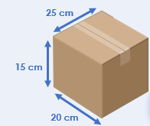
Drill:
- State the unit of mass (in chemistry).
- Calculate the volume of this box.
- Convert this to dm³.

Read Now:
Concentration is the mass of a solute per unit volume of a solution. When sugar is dissolved in water, sugar is the solute, water is the solvent and the sugary water is the solution. The mass of sugar in the given volume of solution is its concentration, so the greater the mass of sugar that is dissolved in the solution, the more concentrated it is. We can calculate concentration in terms of mass per unit volume using the equation: concentration = mass/volume.
- Define concentration.
- Explain the difference between a solute and a solvent.
- Describe the relationship between the mass of a solute that is dissolved in a solution and its concentration.
- State the equation that links concentration, mass and volume.

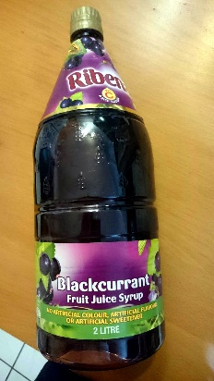
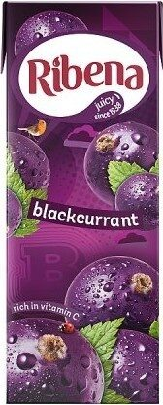
Which is more concentrated?

Volume is the amount of space that a substance or object takes up.
How many units of volume can you think of?

How do you calculate concentration?

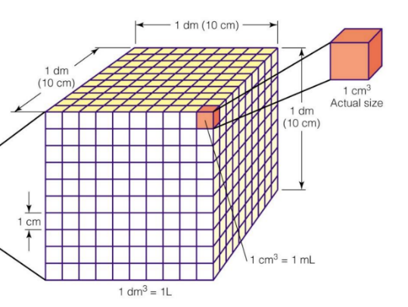
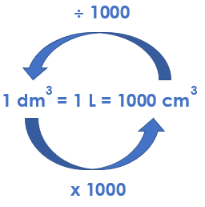
Converting between units of volume
Convert these volumes
1000 cm³ = _______ dm³
5000 cm³ = _______ dm³
2403 cm³ = _______ dm^{3/@#i9}
145 cm³ = _______ dm³
1 dm³ = _______ cm³
10 dm³ = _______ cm³
179 dm³ = _______ cm³
0.2 dm³ = _______ cm³

True or false?
- To convert cm³ into dm³ you need to multiply by 1000.
- 250 cm³ = 0.25 dm³
- 250 cm³ of a 4 g/dm³ solution contains 1 g of solute.
- 0.5 dm³ = 5000 cm³
- 5.5 g of copper sulfate is dissolved in 500 cm³ to form a 11 g/dm³ solution.

Drill
- Define concentration.
- State the equation that links concentration, mass and volume.
- State the unit for mass.
- State the unit for volume
- State the unit for concentration.
- Convert 5000 cm³ into dm³.
- Define solute.
- Define solvent.
- Define solution.

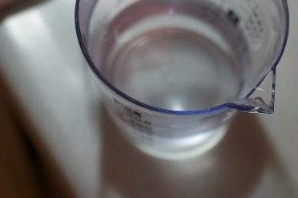
I: Calculating concentration
A scientist makes a solution of salt water. They dissolve 750 g of salt to make up a solution of 1000 cm³.
What is the solute?
What is the solvent?
What is the solution?
What is the concentration of the solution?

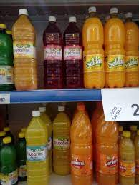
We: Concentration, mass and volume
A manufacturer makes a solution of squash by dissolving 114 g of squash to make 2 dm³ of solution.
What is the concentration of the solution?
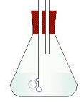
You: Concentration, mass and volume
A scientist makes up a sample of calcium hydroxide solution. 24 g of calcium hydroxide is added to water to make up 200 cm³ of solution.
What is the solute?
What is the solution?
What is the volume in dm³?
What is the concentration of the sample?

Exit Ticket
- Select the answer below which is equal to 0.05 dm³.
  - A. 500 cm³
  - B. 50 cm³
  - C. 0.00005 cm³

- 10 g of a solute was used to make a solution with a volume of 25 dm³. What was the concentration of the solution?
  - A. 250 g/dm³
  - B. 0.4 g/dm³
  - C. 2.5 g/dm³

- 200 cm³ of a solution has a concentration of 25 g/cm3. What mass of solute was dissolved in it?
  - A. 5000 g
  - B. 125 g
  - C. 5 g

Do Now
Taking it Further:
Calculating Concentration

- Define concentration.
- State a unit used to measure concentration.
- Calculate the concentration of 500 cm3 of solution that has 20 g of solute dissolved in it.
- State Avogadro’s number.
- State the equation that links number of moles, mass and relative formula mass.

Drill:
- State the unit for amount of substance.
- Calculate the mass of 1 mole of carbon.
- Calculate the number of moles in 48 g of carbon

Read Now:
Concentration can be measured in terms of grams of solute per unit volume, or in moles per unit volume (usually mol/dm³). We know that concentration = mass/volume, and number of moles = mass/relative formula mass. We can always calculate relative formula mass using the relative atomic masses from the periodic table. This means that we can use these two equations together to work between concentration, volume, mass and number of moles. For example, we want to calculate the mass of sodium hydroxide dissolved in 500 cm³ of 12 mol/dm³ solution, so we can first calculate the amount of substance (number of moles) that would be present in this volume, then use the relative formula mass of sodium hydroxide to determine the mass of this number of moles.
- State the equation that links concentration, mass and volume.
- State the equation that links number of moles, mass and relative formula mass.
- Describe how to calculate the relative formula mass of a compound.
- State the two different units that can be used for concentration.

Concentration
State the two equations to calculate concentration.

Give the two units for concentration.

Worked example: Calculating concentration
A scientist adds 9.75 g of sodium chloride to make 250 cm³ of salt solution.
What is the concentration of the solution in mol/dm³?
Mass = 9.75 g Mr _{r} (NaCl) = 23 + 35.5
$$Number of moles = \frac{mass}{Mr} Number of moles = \frac{9.75}{58.5} Number of moles =0.167 mol$$
$$Concentration= \frac{number of moles}{volume} Concentration= \frac{0.167}{0.25} Concentration=0.67 mol/dm 3$$

We do: Calculating concentration
Some glucose (C₆H₁₂O₆) was dissolved in 500 cm³ of water.
The concentration of the solution was 0.4 mol/dm³.
What mass of glucose was dissolved in the solution?

Drill
- State the equation that links concentration, mass and volume.
- State the equation that links concentration, number of moles and volume.
- State the equation that links number of moles, mass and relative formula mass.
- Define relative formula mass.
- Calculate the relative formula mass of sodium hydroxide (NaOH).
- State the unit for mass.
- State the unit for volume.
- Convert 50 cm³ to dm³.
- State the two units that can be used for concentration.
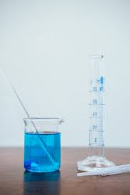
I:
A scientist makes 500 cm³ of copper sulfate solution by dissolving 31.9 g of copper sulfate (CuSO₄) in water. They want to calculate the concentration of the solution in mol/dm³.
What is M_{r} of copper sulfate?

What is the number of moles in the solution?

What is the concentration of the solution in mol/dm³?

We:
A student makes 750 cm³ of a solution of sodium chloride by dissolving 65 g of sodium chloride.

What is M_{r} of sodium chloride?

What is the number of moles in the solution?

What is the concentration of the solution in mol/dm³?

You:
A scientist makes up 250 cm³ of calcium hydroxide solution by adding 24 g of calcium hydroxide (Ca(OH)₂) to water.
What is M_{r} of calcium hydroxide?

What is the number of moles in the solution?

What is the concentration of the solution in mol/dm³?

Exit Ticket
- Calculate the concentration of a 750 cm³ solution that contains 1.5 mol of solute.
  - A. 1.5 mol/dm³
  - B. 0.02 g/dm³
  - C. 2 mol/dm³

- Calculate the number of moles in 2 dm³ of 0.5 mol/dm³ solution.
  - A. 4 mol
  - B. 1 mol
  - C. 0.25 mol

- 80 g of sodium hydroxide (M_{r} = 40) is dissolved in solution. How many moles of solute are in the solution?
  - A. 2 mol
  - B. 0.5 mol
  - C. 3200 mol
Do Now
Taking it Further: Calculating Unknown Concentrations

- State the quantity that is measured with the unit mol/dm³.
- Calculate the concentration (in mol/dm³) of a solution that has 2 moles of solute dissolved in 100 cm³ of solution.
- Complete the following general equation: Acid + Alkali →
- What type of reaction is described in question 3?
- State the colour of universal indicator in an acidic solution.

Drill:
1. What type of solution would have a pH of 10?
2. What type of ions would be present in a solution with a pH of 10?
3. Which electrode would these ions travel towards in electrolysis?

Read Now:
Depression is a serious risk to the mental health of people around the world. Low vitamin D levels in the blood are associated with a greater risk of depression. This is especially concerning for those of us living in the UK and Ireland. This is because humans naturally get our vitamin D from sunlight, which we don’t get a lot of in our countries, especially in winter! Those of us who spend a lot of time indoors, or who wear clothes that cover up most of our skin, are at a greater risk of vitamin D deficiency. Doctors recommend that most people living here take a vitamin D supplement, especially during the winter months when we get the least amount of sunlight. Scientists recently carried out a study to investigate the blood concentration of vitamin D in 56 patients (aged 18-60 years), all of whom had mild to moderate depression. They found that following 8 weeks of vitamin D supplementation, a significant proportion of patients reported a reduction in the severity of their depression.
- What is the relationship between vitamin D and depression?
- Why is this relationship especially important for us to understand in the UK and Ireland?
- Why do doctors recommend that people take vitamin D supplements in the winter months?
- What did scientists find out in their study?

Neutralisation
acid + alkali → _____________ + _________
What pH will the product of a neutralisation have?

How many moles are reacting in each example?
KOH + HCl → KCl + H₂O
____ mole(s) of KOH is/are reacting with _______ mole(s) of HCl to produce ______ mole(s) of KCl and ______ mole()s of water.

2NaOH + H₂SO₄ → Na₂SO₄ + 2H₂O
____ mole(s) of NaOH is/are reacting with _______ mole(s) of sulfuric acid to produce ______ mole(s) of sodium sulfate and ______ mole()s of water.
Drill

- State the equation that links concentration, mass and volume.
- State the equation that links concentration, number of moles and volume.
- State the equation that links number of moles, mass and relative formula mass.
- Write a unit of volume.
- Write a unit of concentration.
- State the mole ratio of acid to alkali for the equation NaOH + HCl → NaCl + H₂O
- Calculate the number of moles for a solution with a volume of 50 cm³ and a concentration of 0.5 mol/dm³.
- Calculate the volume of a solution that contains 0.5 moles of solvent in a solution of concentration 1.5 mol/dm³

Steps to success for calculations

- Write the equation
- Find the number of moles of the reagent of known concentration.
- Deduce the number of moles of the unknown solution
- Calculate the concentration of unknown solution

I: Calculating an unknown concentration

50 cm³ of 0.1 mol/dm³ lithium hydroxide reacts with 30 cm³ of hydrochloric acid.
The equation for the reaction is:
LiOH + HCl LiCl + H₂O
How many moles of lithium hydroxide reacted?

What is the mole ratio of alkali to acid in this reaction?

How many moles of hydrochloric acid reacted?

What is the concentration of the hydrochloric acid?

We: Calculating an unknown concentration
50 cm³ of 0.1 mol/dm³ lithium hydroxide reacts with 30 cm³ of sulfuric acid.
The equation for the reaction is:
2 LiOH + H₂SO₄ _________________ + ________________
How many moles of lithium hydroxide reacted?

What is the mole ratio of alkali to acid in this reaction?

How many moles of sulfuric acid reacted?

What is the concentration of the sulfuric acid?

You: Calculating an unknown concentration
25 cm³ of 0.5 mol/dm³ barium hydroxide reacts with 20 cm³ of hydrochloric acid.
The equation for the reaction is:
Ba(OH)₂ + 2 HCl BaCl₂ + 2 H₂O
How many moles of barium hydroxide reacted?

What is the mole ratio of alkali to acid in this reaction?

How many moles of hydrochloric acid reacted?

What is the concentration of the hydrochloric acid?

Exit Ticket

- What is the equation that links concentration, number of moles and volume?
  - A. $Concentration = \frac{number of moles}{volume}$
  - B. $Number of moles = \frac{concentration}{volume}$
  - C. $Concentration =number of moles × volume$

- Calculate the number of moles in 100 cm³ of 0.2 mol/dm³ solution.
  - A. 20 mol
  - B. 2 mol
  - C. 0.02 mol

Sodium hydroxide reacts with hydrochloric acid:
NaOH + HCl NaCl + H₂O
- What is the mole ratio of alkali to acid in this reaction?
  - A. 1:1
  - B. 4:2
  - C. Need more information

(HT) Amounts of Substances in Equations

Do Now
- Define relative formula mass.
- Calculate the relative formula mass of magnesium chloride (MgCl₂). Mg = 24, Cl = 35.5
- Calculate the percentage by mass of chlorine in magnesium chloride.
- Calculate the number of moles in 47.5 g of magnesium chloride.

Drill:
- Calculate the M_{r} of potassium sulfate (K₂SO₄). K=39, S=32, O=16
- Calculate the M_{r} of aluminium hydroxide (Al(OH)₃). Al=27, O=16, H=1
- Calculate the M_{r} of calcium nitrate (Ca(NO₃)₂). Ca=40, N=14, O=16

Read Now:
- State the number of particles that are present in 1 mole of a substance.
- Describe the reaction between hydrogen and oxygen to form water in terms of moles.
- Describe the reaction between hydrogen and oxygen to form water in terms of molecules.
- Explain why chemical equations must be balanced.
Chemical equations must be balanced because atoms cannot be created or destroyed in a chemical reaction, only rearranged. A balanced chemical equation shows us the ratio in which reactants react or products or made. For example, in the reaction 2H₂ + O₂ 2H₂O, we can see that two molecules of hydrogen react with every oxygen molecule to produce two molecules of water. In real chemical equations, it would be extremely unlikely to just have a couple of molecules reacting, so instead we can use the balanced chemical equation to show us the ratio of moles that are involved. This means that 2 moles of hydrogen react with1 mole of oxygen to produce 2 moles of oxygen. Remember that 1 mole of any substance contains 6.02 x10²³ particles.

Mole Ratios
Complete the tables to show the mole ratios
N₂ + 3 H₂ 2 NH₃
1 mol |  | 2 mol
 | 0.6 mol
 |  | 0.1 mol

3 C + 2 Fe₂O₃ 4 Fe + 3 CO₂

3 mol
0.5 mol
0.1 mol

Moles, Mass and M_{r}
2 Mg + O₂ 2 MgO
Name the steps to calculate the mass of magnesium oxide that could be made from reacting 12 g of magnesium with oxygen.

Identify the mistake(s) in this working.
2 H₂ + O₂ 2 H₂O
Calculate the mass of water that could be made from reacting 8 g of hydrogen with oxygen.
mole ratio = 2 : 2
mole ratio = 1: 1
$$number of moles hydrogen = \frac{mass}{Mr} number of moles H2= \frac{8}{4} number of moles H2=2 mol$$
$$number of moles H2O=2 mol$$
$$number of moles H2O= \frac{mass}{Mr} 2 mol= \frac{mass}{36} mass=72 g$$

Drill
- State the equation that links number of moles, mass and M_{r}.
- Define relative formula mass.
- State the units for mass.
- State the units for number of moles.
- Calculate the relative formula mass of ammonia (NH₃).
- Calculate the relative formula mass of sodium oxide (Na₂O).
- Calculate the number of moles in 34 g of ammonia.
- Calculate the number of moles in 15.5 g of sodium oxide.
- Calculate the mass of 0.1 moles of ammonia.
- Calculate the mass of 0.05 moles of sodium oxide.

I: calculating reacting masses
CH₄ + 2 O₂ 2 H₂O + CO₂
Calculate the mass of methane that burns to produce 5.5 g of carbon dioxide.
mole ratio =
Moles of carbon dioxide =

Moles of methane =
Mass of methane =

We: calculating reacting masses
Calculate the mass of aluminium oxide needed to make 108 g of aluminium.
Al₂O₃ + 2 Fe Fe₂O₃ + 2 Al
mole ratio =
Moles of aluminium =

Moles of aluminium oxide =

Mass of aluminium oxide =

You: calculating reacting masses
N₂ + 3 H₂ 2 NH₃
Calculate the mass of hydrogen needed to make 120 g of ammonia.

mole ratio =
Moles of ammonia=

Moles of hydrogen=

Mass of hydrogen =

Exam question
1. Read the question and the student’s answer carefully.
2. Use the mark scheme to award the student a number of marks and annotate their answer with suggestions to improve.
Stretch: Rewrite the answer to show how it should be done!
Question:
Aluminium can be separated from its ore by electrolysis. The equation for the reaction is:
2 Al₂O₃ (l) 4 Al (s) + 3 O₂ (g)
Calculate the mass of aluminium that could be obtained from 2 kg of aluminium oxide. (6)

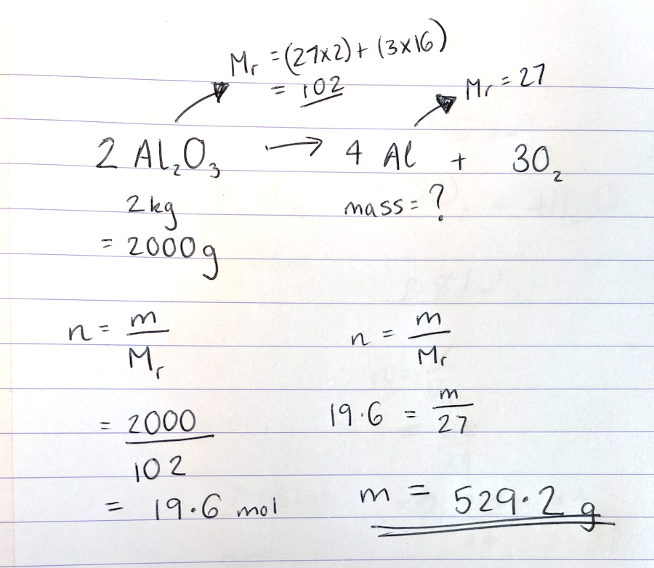

Marks awarded= _______ Mark scheme:

Point | Mark
Mr Al₂O₃ = 102 | 1 (answer, can also be shown in working of next point)
Number of moles Al₂O₃ = m/Mr  2000/102 | 1 (substitution)
Number of moles Al₂O₃ = 19.6.078…mol | 1 (answer)
Mole ratio= 2:4  Number of moles Al = 39.2156… | 1 (number of moles Al)
Mass Al = n x Mr  = 39.2156 x 27 | 1 (substitution)
1 058.82 g | 1 (answer)

Exit Ticket
- 12 g of magnesium burns in oxygen. Calculate the number of moles of magnesium that reacted.
  - A. 12 mol
  - B. 2 mol
  - C. 0.5 mol
- Calculate the number of moles of oxygen that would have reacted.
  - A. 1.0 mol
  - B. 0.5 mol
  - C. 0.25 mol
- Calculate the mass of oxygen that would have reacted.
  - A. 4 g
  - B. 8 g
  - C. 128 g

Do Now
(HT) Limiting Reactants

- State which side of a chemical equation the reactants are found on.
- Explain why chemical equations must be balanced.
- Calculate the relative formula mass of sodium carbonate (Na₂CO₃).
- Calculate the mass of 0.2 moles of sodium carbonate.
- Calculate the number of moles in 100 g of sodium carbonate.

Drill:
- Calculate the M_{r} of lithium nitrate (LiNO₃). L=7, 7=14, O=16
- Calculate the M_{r} of copper carbonate (CuCO₃). Cu=63.5, C=12, O=16
- Calculate the M_{r} of calcium phosphate (Ca₃(PO₄)₂). Ca=40, P=31, O=16

Read Now:
We can use mole ratios to determine the numbers of particles involved in chemical reactions. We can use a given mass of a reactant to determine the number of moles that were reacting and therefore the number of moles of product that would be made. In reactions where there are two or more reactants, the reactant that has the fewest number of moles is the limiting reactant. This means that it will limit the amount of product that can be made. For example a car factory has made 10 car frames and 100 wheels. This would be enough wheels to make 25 cars, because each car needs 4 wheels, but there are only enough frames to make 10 cars. In this case, the car frame is the limiting reactant, because it determine the maximum amount of product (cars) that can be made.
- Explain what is meant by a limiting reactant.
- Identify the limiting reactant in the car factory example.
- Explain why this is the limiting reactant.
- Suggest which would be the limiting reactant if the car factory had made 30 car frames instead.

Limiting Reactants
How many cars can be made in each scenario?
Identify what is in excess, and what is the limiting reactant


1. +


2.

+

3.

+

Calculate the mass of potassium oxide that can be made from 78 g of potassium and 32 g of oxygen.
4 K + O₂ 2 K₂O
mole ratio =
Moles of K=

Moles of O₂ =

Moles of oxygen needed to react with 78g K =
Moles of K needed to react with 32g oxygen =
Limiting reactant = Reactant in excess =
Moles of K₂O made =
Mass of K₂O made

Drill

- State the equation that links number of moles, mass and M_{r}.
- Explain what is meant by a limiting reactant.
- Explain what it means for a reactant to be in excess.
- Describe where reactants and products are found in a chemical equation.
- State the units for number of moles.

I: using limiting reactants in calculations
CH₄ + 2 O₂ 2 H₂O + CO₂
Calculate the mass of carbon dioxide that would be formed when 32 g of methane burns in 100 g of oxygen.
mole ratio =
$$n {CH}_{4}= \frac{mass}{Mr} n {CH}_{4}= \frac{}{} n {CH}_{4}= mol$$
$$n{ O}_{2}= \frac{mass}{Mr} n { O}_{2}= \frac{}{} n { O}_{2}= mol$$
$$number of moles of { O}_{2} needed to react with 32g {CH}_{4}= mol$$
$$number of moles of {CH}_{4} needed to react with100g of { O}_{2}= mol$$
Mole ratio limiting reactant: deisired product =
$$number of moles { CO}_{2}= mol$$
$$number of moles { CO}_{2}= \frac{mass}{Mr} mol= \frac{mass}{}$$
$$mass= g$$

We: using limiting reactants in calculations
Al₂O₃ + 2 Fe Fe₂O₃ + 2 Al
Calculate the mass of aluminium that could be made from 180 g of aluminium oxide and 180 g of iron.
mole ratio =
$$n {Al}_{2}O_{3}= \frac{mass}{Mr} n {Al}_{2}O_{3}= \frac{}{} n {Al}_{2}O_{3}= mol$$
$$n Fe= \frac{mass}{Mr} n Fe= \frac{}{} n Fe= mol$$
$$number of moles of Fe needed to react with 180g {Al}_{2}O_{3}= mol$$
$$number of moles of {Al}_{2}O_{3} needed to react with 180g of Fe= mol$$
Mole ratio limiting reactant: deisired product =
$$number of moles Al= mol$$
$$number of moles Al= \frac{mass}{Mr} mol= \frac{mass}{}$$
$$mass= g$$

You: using limiting reactants in calculations
N₂ + 3 H₂ 2 NH₃
Calculate the mass of ammonia that could be made from 50 g of nitrogen and 50 g of hydrogen.
mole ratio =
$$n N_{2}= \frac{mass}{Mr} n N_{2}= \frac{}{} n N_{2}= mol$$
$$n H_{2}= \frac{mass}{Mr} n H_{2}= \frac{}{} n H_{2}= mol$$
$$number of moles of H_{2} needed to react with 50g N_{2}= mol$$
$$number of moles of N_{2} needed to react with50g of H_{2}= mol$$
Mole ratio limiting reactant: deisired product =
$$number of moles {NH}_{3}= mol$$
$$number of moles {NH}_{3}= \frac{mass}{Mr} mol= \frac{mass}{}$$
$$mass= g$$
Exit Ticket

2 Mg + O₂ 2 MgO 48 g of magnesium burns in 100 g of oxygen

- Calculate the number of moles of magnesium present.
  - A. 0.5 mol
  - B. 1 mol
  - C. 2 mol

- Calculate the number of moles of oxygen present.
  - A. 6.25 mol
  - B. 3.125 mol
  - C. 0.32 mol

- Which is the limiting reactant?
  - A. Mg
  - B. O₂
  - C. MgO

Do Now
Prior Knowledge Review:
Reactions of Acids
- Calculate the M_{r} of sulfuric acid (H₂SO₄). H=1, S=32, O=16
- Calculate the percentage by mass of hydrogen in sulfuric acid.
- Name another acid.
- State the pH range of acids.
- State the colour that Universal Indicator would turn in an alkaline solution.

Drill:
- State the chemical formula for water.
- State the chemical formula for carbon dioxide.
- Use calculations to show whether water or carbon dioxide contains a greater percentage by mass of oxygen.

Read Now:
Acids can be neutralised by alkalis (which are usually soluble metal hydroxides, like sodium hydroxide) and bases (which are insoluble metal hydroxides, like calcium hydroxide, metal oxides, like copper oxide and metal carbonates, like potassium carbonate). The reaction between an acid and a metal or a metal compound always produces a salt. If an acid reacts with a metal oxide or hydroxide, a salt and water are formed and if an acid reacts with a metal carbonate, a salt, water and carbon dioxide are formed. Sodium chloride is one example of a salt, but a salt is any compound made from a reaction between a metal and an acid.
- Define a salt.
- Write a general equation for a reaction between an acid and a metal oxide.
- Write a general equation for a reaction between an acid and a metal hydroxide.
- Write a general equation for a reaction between an acid and a metal carbonate.
- Give an example of a salt.

The pH scale
Label acid, neutral and alkaline on the scale
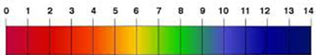
Complete the equations for neutralisation reactions
Acid + alkali ________________ + ___________________
Acid + base ________________ + ___________________
Acid + Metal Carbonate ________________ + ___________________ +___________________________
Most bases are i________________. Alkalis are ______________ bases
Oxides are ____________________
Carbonates are ________________________.

Naming salts
Name of acid | Ending of salt name
Hydrochloric acid
 | Nitrate
Sulfuric acid
 | Phosphate

Acids and Metals
Acids react with metals to product s_______ ___ and h______________
__________________ + hydrochloric acid → magnesium chloride + ____________________
This is not a ____________________________ reaction.
It is a d________________________ or r___________________ reaction

Testing for Gases
Complete the table for the gas tests
Name of gas | Test method | Positive result
Hydrogen
Carbon dioxide

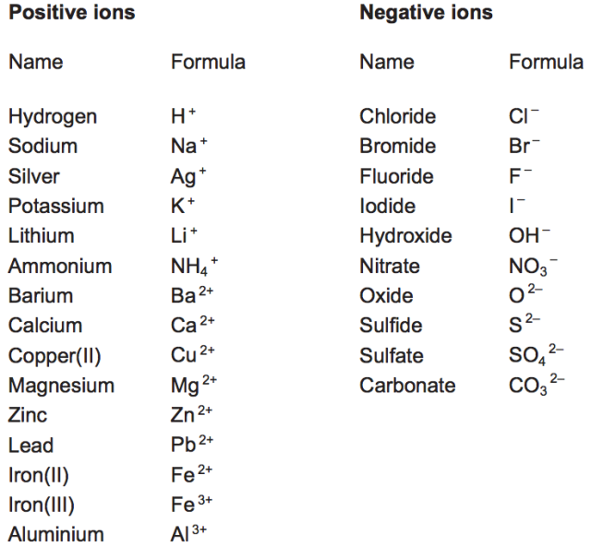
(HT) Writing ionic equations

Ionic equations tell us only what has reacted, not all the ions present. For example:
Mg_{(s)} + H₂SO_{4(aq)} → MgSO_{4(aq)} + H_{2(g)}
Look at this chemical equation:
We can use 2 steps to write this as an ionic equation:
Step 1: Split up the aqueous (aq) substances into their ions
Mg_{(s)} + 2H⁺_{(aq)} + SO₄²⁻_{(aq)} → Mg²⁺_{(aq)} + SO₄²⁻_{(aq)} + H_{2(g)}

Step 2: Delete the spectator ions (the ones that appear on both sides) – in this case the sulfate ions
Mg_{(s)} + 2H⁺_{(aq)} → Mg²⁺_{(aq)} + H_{2(g)}
Magnesium has lost electrons, has been oxidised, to magnesium ions.
Hydrogen has gained electrons, been reduced, to hydrogen atoms which then form molecules

Drill
- State the general equation for the reaction between an acid and an alkali.
- State the general equation for the reaction between an acid and an metal carbonate.
- State the general equation for the reaction between an acid and a metal.
- Describe a positive test for hydrogen.
- Describe a positive test for carbon dioxide.
- True or false: the reaction between an acid and a metal is an example of neutralisation.

I: predicting the products of a reaction
A student reacts hydrochloric acid with magnesium carbonate.
What salt would be produced in this reaction?
What would the other product(s) of this reaction be?
Write this as a word equation.
How could you test for the presence of carbon dioxide?
What type of reaction is this?

We: predicting the products of a reaction
A student reacts copper oxide with sulfuric acid.
What salt would be produced in this reaction?
What would the other product(s) of this reaction be?
Write this as a word equation.
What would the products of these show for the squeaky pop test?
What type of reaction is this?

You: predicting the products of a reaction and comparing
A student reacts nitric acid with zinc.
What salt would be produced in this reaction?
What would the other product(s) of this reaction be?
Write this as a word equation.
How could you test for the presence of hydrogen?
What type of reaction is this?

Compare: to outline the similarities and/or differences between things
Compare the products of a reaction between an acid and an alkali and an acid and a metal carbonate.
To ‘compare’, your answer should:
- Give similarities.
- Write paired statements that show differences relating to the same feature.
- Use the term ‘whereas’ to link your statements.

_________________________________________________________________________________________
_________________________________________________________________________________________
_________________________________________________________________________________________
_________________________________________________________________________________________
_________________________________________________________________________________________
_________________________________________________________________________________________
_________________________________________________________________________________________
_________________________________________________________________________________________
_________________________________________________________________________________________
_________________________________________________________________________________________
Exit Ticket

- Name the salt that would be produced when hydrochloric acid reacted with potassium hydroxide.
  - A. Potassium hydride
  - B. Potassium chloride
  - C . Potassium chlorine

2. The products of which reaction would give a positive squeaky pop test?
  - A. Nitric acid + calcium oxide
  - B. Nitric acid + calcium carbonate
  - C. Nitric acid + calcium

- Which of these is not a neutralisation reaction?
  - A. Acid + metal
  - B. Acid + metal hydroxide
  - C. Acid + metal carbonate

Do Now
Acids, Alkalis and Neutralisation

- State the chemical formula for hydrochloric acid.
- State the general equation for the reaction between an acid and an alkali.
- Name the salt that would be produced from a reaction between calcium hydroxide and sulfuric acid.
- Calculate the M_{r} of sodium hydroxide (NaOH). Na=23, O=16, H=1
- Sodium hydroxide is an alkali. What colour would Universal Indicator turn when added to sodium hydroxide solution?

Drill:
- State the pH of a neutral solution.
- A substance has a pH of 4.7. It is an acid or a base?
- Is a pH of 4.7 likely to be detected from Universal Indicator or a pH probe?

Read Now:
The pH scale is a measure of the acidity or alkalinity of a solution. It measures from 0-14, where pH 7 is neutral, pH values lower than 7 are acidic and pH values greater than 7 are alkaline. The pH scale is an unusual scale in that a one point increase is equivalent to a ten-fold increase or decrease in acidity or alkalinity. For example, pH 2 is 10 times more acidic than pH 3. Litmus paper can be used to show whether a substance is acidic or alkaline but cannot give a pH value. pH values can be measured using Universal Indicator or a pH probe. Universal Indicator turns different colours in acidic and alkaline solutions which can be matched to a colour chart. A pH probe gives a more precise measurement, as it can give a value with a decimal place.
- Explain what the pH scale measures.
- Explain why the pH is an unusual scale.
- State the pH of a neutral solution.
- Describe two ways that pH can be measured.
- Give an advantage of a pH probe over Universal Indicator.

The pH Scale and indicators

Name two ways to measure pH
______________________________________________________________________________________________

What colour would universal indicator turn in a solution of:
a) pH 7
b) pH 3
c) pH 9
d) pH 0
Which ion do acids produce in aqueous solutions? _________
Which ion do alkalis produce in aqueous solutions? __________
What is the ionic equation for neutralization? _________________ ________
Complete the table for naming salts
Name of acid | Ending of salt name
 | Chloride
Nitric acid | Nitrate
Sulfuric acid
 | Phosphate

Name the salts that would be produced in each reaction
- Sodium hydroxide + hydrochloric acid→
- Potassium hydroxide + nitric acid →
- Lithium hydroxide + sulfuric acid →
- Barium hydroxide + hydrochloric acid →
- Sodium hydroxide + sulfuric acid→
- Lithium hydroxide + nitric acid →

Drill
- State the pH of neutral solutions.
- State the pH of acidic solutions.
- State the pH of alkaline solutions.
- Describe two ways of measuring pH.
- Name the ion that acids produce in aqueous solutions.
- Name the ion that alkalis produce in aqueous solutions.
- State the general equation for the reaction between an acid and an alkali.
- Name the type of salts formed from hydrochloric acid.
- Name the type of salts formed from sulfuric acid.
- Name the type of salts formed from nitric acid.

I: determining chemical formula
A student reacts hydrochloric acid with lithium hydroxide.
What salt would be produced in this reaction?

What would the other product(s) of this reaction be?
Write this as a word equation.

Use the ion sheet to determine the chemical formula of the salt.

How is the water formed?

We: determining chemical formula
A student reacts potassium hydroxide with sulfuric acid.
What salt would be produced in this reaction?
What would the other product(s) of this reaction be?
Write this as a word equation.
Use the data sheet to determine the chemical formula of the salt.

You: determining chemical formula
A student reacts nitric acid with barium hydroxide.
What salt would be produced in this reaction?
What would the other product(s) of this reaction be?
Write this as a word equation.
Use the data sheet to determine the chemical formula of the salt.

Read the exam style question carefully, then fill in each section below.
Question: A student reacts different alkalis with different acids.
- Write a word equation to show the reaction between sodium hydroxide and sulfuric acid. (2)

- Barium hydroxide reacts with nitric acid. The equation for the reaction is:

Ba(OH)₂ + HNO₃ Ba(NO₃)₂ + H₂O

Balance this equation. (1)
Calculate the relative formula mass of nitric acid. (2)
Calculate the percentage by mass of oxygen in nitric acid. (3)

Section 1: At first glance
1. What command words are used in this question? Circle them clearly.
2. Underline the key information in the question above.
3. How many marks is this question worth?
Section 2: Thinking ahead
Read the question again.
What do you need to know in order to answer this question really well?
Can you split the question into two or more parts?
Are there any labelled diagrams that might help you to show your answer?
What are the key words that you should include in your answer?
Section 4: Space to plan
Use this space to plan your answer.

Section 4: Answer the question
________________________________________________________________________________________________________________________________________________________________________________________________________________________________________________________________________________________________________________________________________________________________________________________________________________________________________________________________________________________________________________________________________________________________________________________________________________________________________________________________________________________________________________________________________________________________________________________________________________________________________________________________________________________________________________________________________________________________________________________________________________________________________________________________________________________________________________________________________________________________________________________________________________________________________________________________________________________________________________________________________________________________________________________________________________________________________________________________________________________________

Exit Ticket

- Identify the ion that is produced by acids in aqueous solutions.
  - A. H⁺
  - B. OH⁻
  - C. H₂O

- Name the salt that would be produced when sulfuric acid reacts with lithium hydroxide?
  - A. Lithium hydride
  - B. Lithium sulfide
  - C. Lithium sulfate

- What is the correct ionic equation when an acid is neutralised by an alkali?
  - A. H₂O H⁺ + OH⁻
  - B. H + OH H₂O
  - C. H⁺ + OH⁻ H₂O

Taking it Further: RPA Determining an Unknown Concentration by Titration

Do Now
- State the formula for sulfuric acid.
- Calculate the relative formula mass of sodium hydroxide (NaOH).
- Write a word equation for the reaction between sulfuric acid and sodium hydroxide.
- What type of reaction is this?
- Name the salt that would be produced in a reaction between hydrochloric acid and potassium hydroxide.

Drill:
- Describe three ways to tell if a substance is acidic.
- State the colour that Universal Indicator would turn in an acid.
- Give a disadvantage of Universal Indicator.

Read Now:
Titrations are a method of quantitative analysis. This means that they provide numerical information, unlike in a qualitative analysis. For example, in a titration, you can determine a volume of acid required to neutralise an alkali. This is a numerical quantity. However, in a qualitative analysis, a numerical value is not given. An example of a qualitative analysis that we have seen already is using different food tests to identify the presence of different nutrients. Iodine can be used to test for the presence of starch. If starch is present, iodine turns blue-black. These reagents can show whether or not a nutrient is present, but cannot tell you how much of a nutrient is present. The starch test is also useful when identifying if a leaf has produced starch, showing that it has been converted from glucose produced in photosynthesis.
- Give an example of a quantitative analysis.
- Explain what is meant by a quantitative analysis.
- Explain the difference between a quantitative analysis and a qualitative analysis.
- Describe the result of a positive test for starch.

Titration demonstration – Complete the paragraph to name the pieces of equipment and measurements needed
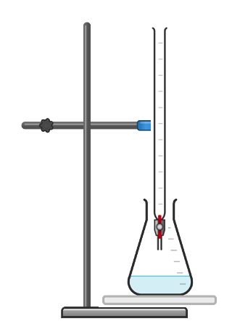
- Measure 25 cm³ of alkali using a _________________
- Add the alkali to a ________________ ____________
- Set up a ______________ with acid. Rinse the ______________ with the acid solution and flush the tap to remove air bubbles
- Add a few drops of indicator (phenolphthalein) to the ____________flask
- Place the conical flask on a ____________ ______________
- Record the starting volume of acid in the ___________
- Open the tap to gradually add acid from the ____________ to the __________ ___________ , while swirling the conical flask
- When the indicator changes colour, this is the end-point of the titration
- Use the starting and final volumes on the burette to determine the volume of acid used

Questions about the method and accuracy
What will the colour change be when adding acid to alkali for:
a) Phenolphthalein __________________ to __________________
b) Methyl orange__________________ to __________________
Resolution is the smallest _______________ on the equipment
The uncertainty is ______________ the resolution
What steps do we take to make our measurements as accurate as possible?
The first one has been completed for you
Step taken in the method | Why does this make the measurement accurate?
Rinsing the burette | to make sure there is no other solution in the burette that would affect the concentration of the acid
Adding acid from the burette gradually/drop by drop
Swirling the conical flask while adding acid

Using a white tile

Reading volume of liquid from the centre of the meniscus at eye level
- Give the name for the volume of liquid that is measured using a titration.
Drill
- Define concordant results.
- Describe the function of the indicator in a titration.
- Describe the function of the white tile in a titration.
- Define the end-point of a titration.
- Name the piece of equipment that should be used to measure a fixed volume.
- Name the piece of equipment that should be used to measure a variable volume.

I: identifying concordant results
Titration | Volume of acid used (cm³)
1 | 34.5
2 | 31.2
3 | 31.1
4 | 31.3
5 | 31.2
A student uses a titration to determine the volume of sulfuric acid needed to neutralise 25 cm³ of sodium hydroxide solution.
Their results are shown in the table.
Which values from the table are concordant measurements?
Which might the measurement from titration 1 be different from the others?
What is the mean volume of acid used?

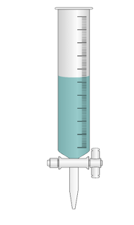
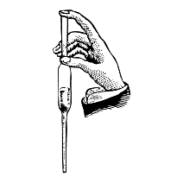
We: measuring volume and uncertainty

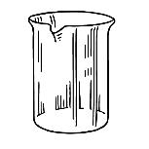
Different instruments can be used to measure volumes of liquids.
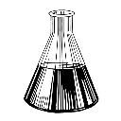
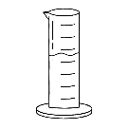

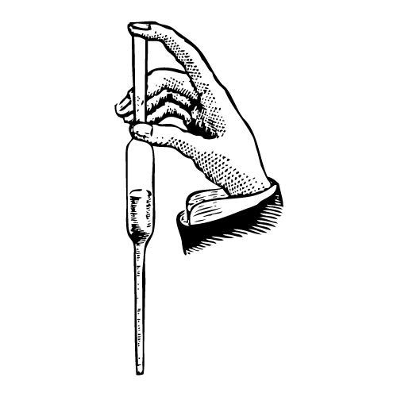
What instruments could be used to measure the volume of a liquid?
______________________________________________________________________________________
______________________________________________________________________________________
What instruments would allow the most precise measurements to be taken? Why?
______________________________________________________________________________________
______________________________________________________________________________________
______________________________________________________________________________________
A measuring cylinder has a resolution of 1 cm³. Calculate the uncertainty when using this to measure a liquid.
______________________________________________________________________________________
A pipette has a resolution of 0.1 cm³. Calculate the uncertainty when using this to measure a liquid.
______________________________________________________________________________________

You: explaining the purpose of equipment
They use 40 cm³ of 0.75 mol/dm³ nitric acid solution. A student uses a titration to determine the concentration of calcium hydroxide.What piece of equipment should be used to measure the volume of nitric acid? Why?
______________________________________________________________________________________
______________________________________________________________________________________
What piece of equipment should be used to measure the volume of calcium hydroxide that is added. Why?
______________________________________________________________________________________
______________________________________________________________________________________
Why is a white tile placed underneath the conical flask?
______________________________________________________________________________________
Why should an indicator such as phenolphthalein or methyl orange be used instead of Universal Indicator?
______________________________________________________________________________________
______________________________________________________________________________________

Required Practical Activity: Determining an Unknown Concentration by Titration
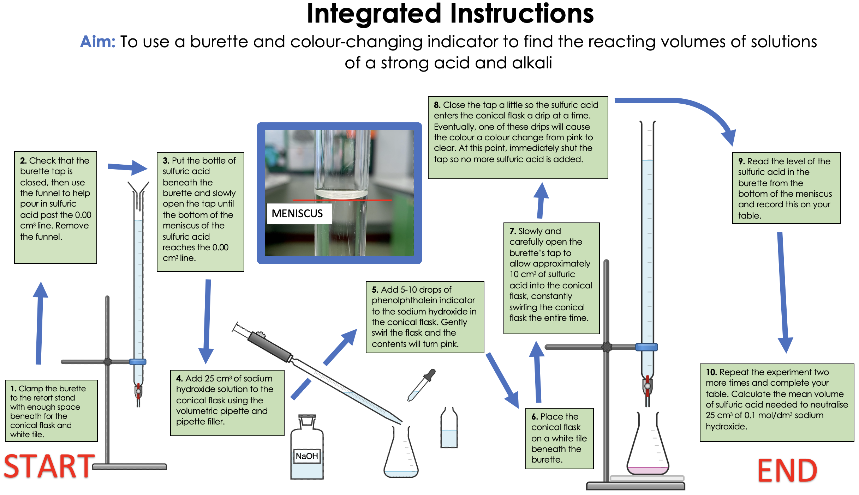
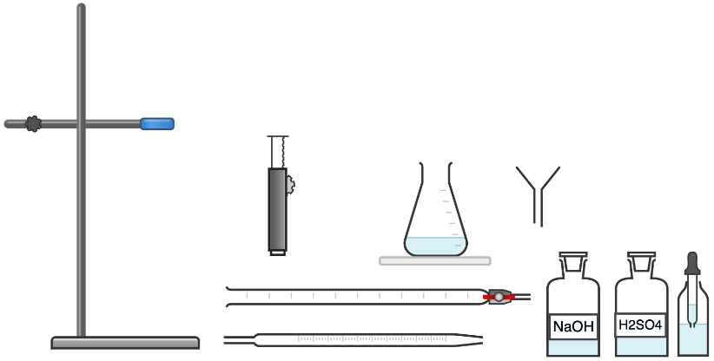
Apparatus:
- 25 cm³ volumetric pipette
- Pipette filler
- 50 cm³ burette
- 250 cm³ conical flask
- Funnel
- Clamp stand and clamp
- White tile

Chemicals:
- 0.1 mol/dm³ sodium hydroxide solution (irritant)
- ‘Unknown concentration’ sulfuric acid
- Phenolphthalein indicator
Method:
- Clamp the burette to the retort stand with enough space beneath for the conical flask and white tile.
- Check that the burette tap is closed, then use the funnel to help pour in sulfuric acid past the 0.00 cm³ line. Remove the funnel.
- Put the bottle of sulfuric acid beneath the burette and slowly open the tap until the bottom of the meniscus of the sulfuric acid reaches the 0.00 cm³ line.
- Add 25 cm³ of sodium hydroxide solution to the conical flask using the volumetric pipette and pipette filler.
- Add 5-10 drops of phenolphthalein indicator to the sodium hydroxide in the conical flask. Gently swirl the flask and the contents will turn pink.
- Place the conical flask on a white tile beneath the burette.
- Slowly and carefully open the burette’s tap to allow approximately 10 cm³ of sulfuric acid into the conical flask, constantly swirling the conical flask the entire time.
- Close the tap a little so the sulfuric acid enters the conical flask a drip at a time. Eventually, one of these drips will cause the colour a colour change from pink to clear. At this point, immediately shut the tap so no more sulfuric acid is added.
- Read the level of the sulfuric acid in the burette from the bottom of the meniscus and record this on your table.
- Repeat the experiment two more times and complete your table. Calculate the mean volume of sulfuric acid needed to neutralise 25 cm³ of 0.1 mol/dm³ sodium hydroxide.
Results:
Rec0rd your results in the following table.
Titre | 1 | 2 | 3 | 4 | 5 | Mean
Volume of acid needed to neutralise alkali (cm³)

Identify concordant results (results that are within 0.2 cm³ of each other) and use these to calculate the mean volume of acid needed to neutralise the alkali.
Read the exam style question carefully, then fill in each section below.
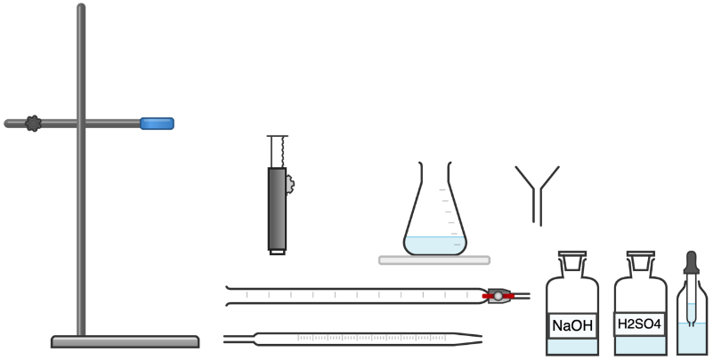
Question:A student wants to determine the volume of a sample of sodium hydroxide that reacts with 25 cm³ of 0.1 mol/dm³ sulfuric acid. The apparatus they can use is shown below.
a) Describe a method that could be used to find the volume of sodium hydroxide that reacts with the sulfuric acid. (6)
b) Describe how they could use measurements to calculate the concentration of the sodium hydroxide. (3)

Section 1: At first glance
1. What command words are used in this question? Circle them clearly.
2. Underline the key information in the question above.
3. How many marks is this question worth?
Section 2: Thinking ahead
Read the question again.
What do you need to know in order to answer this question really well?
Can you split the question into two or more parts?
Are there any labelled diagrams that might help you to show your answer?
What are the key words that you should include in your answer?
Section 4: Space to plan
Use this space to plan your answer.

Section 4: Answer the question
________________________________________________________________________________________________________________________________________________________________________________________________________________________________________________________________________________________________________________________________________________________________________________________________________________________________________________________________________________________________________________________________________________________________________________________________________________________________________________________________________________________________________________________________________________________________________________________________________________________________________________________________________________________________________________________________________________________________________________________________________________________________________________________________________________________________________________________________________________________________________________________________________________________________________________________________________________________________________________________________________________________________________________________________________________________________________________________________________________________________
Exit Ticket

- What is the end point of a titration?
  - A. When the acid/alkali has been completely neutralised
  - B. When all of the acid/alkali has been used up
  - C. The volume used to complete the titration

- Which explains why an indicator such as phenolphthalein is used for titration rather than Universal Indicator?
  - A. It has an obvious colour change
  - B. It speeds up the reaction
  - C. It is cheaper and easier to obtain

- Which is the most appropriate piece of apparatus to measure a volume of 25 cm³?
  - A. A measuring cylinder
  - B. A conical flask
  - C. A pipette

Do Now
Taking it Further:
Titration Calculations
- State two possible units for concentration.
- Define concentration.
- State the equation that links amount of substance (number of moles), concentration and volume.
- Calculate the relative formula mass of sodium hydroxide (NaOH).
- Calculate the concentration when 0.25 mol of sodium hydroxide is dissolved to make 200 cm³ of solution.

Drill:
- State the unit for amount of substance.
- State the unit for volume.
- Convert 50 cm³ to dm³.

Read Now:
Titrations are used to determine the concentration of reactant, based on the known concentration of another reactant. However, these titrations rely on colour changes being seen from the action of an indicator, such as phenolphthalein. But what happens for scientists that are colour-blind or visually impaired? Scientists at the Indian Institute of Science Education and Research in Kolkata have designed a smartphone app that can be used as a multi-sensory tool for detecting the end point of a titration. The app uses the phone’s camera to identify the end point of the titration, notifying the investigator that the titration is complete.
- Describe the function of a titration.
- Explain what is meant by the end point of a titration.
- Explain the function of an indicator in a titration.
- Briefly describe how this app could be useful to visually impaired scientists.

Which values should we use?
Titration | Volume of alkali used (cm³)
1 | 24.2
2 | 21.80
3 | 21.75
4 | 21.80
5 | 21.75
They obtain these results for the volume of alkali needed to neutralise a known volume and concentration of acid. A student performs a titration 5 times.
The student want to use the values to determine the concentration of the alkali.
What values should they use? Why?
_________________________________________________________
How should they use these results?
_________________________________________________________________
What is the name for these results?
___________________________________________________________________
What do these results fall within?
____________________________________________________________________________________________

Drill

- Describe the function of a titration.
- Give the name for the volume of liquid that is measured using a titration.
- Define concordant results.
- State the equation that links concentration, number of moles and volume.
- State the unit for concentration.
- State the unit for number of moles.
- State the unit for volume that should be used in calculations.
- Convert 25 cm³ to dm³.
Titration | Volume of alkali used (cm³)
1 | 27.20
2 | 26.40
3 | 26.45
4 | 26.10
5 | 26.50
I: calculating an unknown concentration
A student uses a titration to determine the concentration of lithium hydroxide. They use 25 cm³ of 0.5 mol/dm³ hydrochloric acid.
They repeated the titration 5 times, and their results for the volume of alkali needed to neutralise the acid are shown in the table.
The equation for the reaction is:
LiOH + HCl LiCl + H₂O
Which values from the table should be used?
____________________________________________________
What is the mean volume of alkali used?

How many moles of acid reacted? $concentration= \frac{number of moles}{volume}$

How many moles of alkali reacted?
Mole ratio = $number of moles =$
What is the concentration of alkali?
$concentration= \frac{number of moles}{volume}$ $concentration= __________________$ =

We: calculating an unknown concentration
A student uses a titration to determine the concentration of a sulfuric acid sample.
They use 50 cm³ of 0.1 mol/dm³ sodium hydroxide solution.
They required 34.5 cm³ of sulfuric acid to neutralise the sodium hydroxide.
The equation for the reaction is:
2 NaOH + H₂SO₄ Na₂SO₄ + 2 H₂O
How many moles of alkali reacted? $concentration= \frac{number of moles}{volume}$

How many moles of acid reacted?
Mole ratio = $number of moles =$
What is the concentration of acid?
$concentration= \frac{number of moles}{volume}$ $concentration= __________________$ =
You: calculating an unknown concentration
A student uses a titration to determine the concentration of calcium hydroxide.
They use 40 cm³ of 0.75 mol/dm³ nitric acid solution.
They required 19.5 cm³ of calcium hydroxide to neutralise the nitric acid.
The equation for the reaction is:
Ca(OH)₂ + 2 HNO₃ Ca(NO₃)₂ + 2 H₂O
How many moles of acid reacted? $concentration= \frac{number of moles}{volume}$

How many moles of alkali reacted?
Mole ratio = $number of moles =$
What is the concentration of alkali?
$concentration= \frac{number of moles}{volume}$ $concentration= __________________$ =
What mass of alkali was dissolved in the given volume of solution?

Exit Ticket

- What is the purpose of a titration?
  - A. To determine an unknown concentration
  - B. To determine how long it takes for an acid to react with an alkali
  - C. To produce a neutralisation reaction

- What is the function of an indicator in a titration?
  - A. To signify the end point of a titration
  - B. To speed up the titration
  - C. To show the concentration of a substance

- What is the concentration of 25 cm³ sodium hydroxide solution that neutralises 20 cm³ of 0.2 mol/dm³ hydrochloric acid solution?
The equation for the reaction is:
NaOH + HCl NaCl + H₂O
  - A. 0.004 mol/dm³
  - B. 0.00001 mol/dm³
  - C. 0.16 mol/dm³
Do Now
(HT) Strong and Weak Acids

- State the chemical formula for hydrochloric acid.
- State the chemical formula for sulfuric acid.
- State the pH range of acids.
- Calculate the relative formula mass of nitric acid (HNO₃).
- Calculate the percentage by mass of hydrogen in nitric acid.

Drill:
- Name the salt that would be produced in a reaction between hydrochloric acid and copper oxide.
- Name the salt that would be produced in a reaction between nitric acid and calcium hydroxide.
- Name the salt that would be produced in a reaction between sulfuric acid and lithium carbonate.

Read Now:
When a solute dissolves in a solvent, a solution is formed. Acids in solution are another example of a solute being dissolved in a solvent. The concentration of the solution is a measure of how much solute is present per unit volume. A concentrated solution has lots of solute per unit volume and a dilute solution has much less solute per unit volume. The concentration of an acid affects its pH, but pH is also affected by the strength of an acid. A strong acid, such as hydrochloric acid, is one which fully dissociates into ions solution. This means that in solution, it splits completely into H⁺ and Cl⁻ ions. A weak acid, such as ethanoic acid, is one which does not fully dissociate into ions in solution.
- Define a solution.
- Explain the difference between a concentrated and a dilute solution.
- Explain what is meant by a strong acid.
- Give an example of a strong acid.
- Explain what is meant by a weak acid.
- Give an example of a weak acid.

pH
What does pH tell us? ___________________________________________________
Which ion is produced by all acids? ___________________________________________________
Name the two factors that affect pH ___________________________________________________
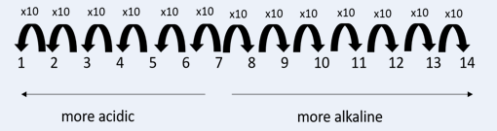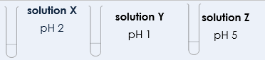
- How does the hydrogen ion concentration of Solution X and Y compare?
  - Y has twice the hydrogen ion concentration of X
  - Y has 10 times the hydrogen ion concentration of X
  - X has 10 times the hydrogen ion concentration of Y

- How does the hydrogen ion concentration of Solution X and Z compare?
  - X has 1000 times the hydrogen ion concentration of Z
  - Z has 1000 times the hydrogen ion concentration of X
  - X has three times the hydrogen ion concentration of Z

- How does the hydrogen ion concentration of Solution Y compare with Z?
  - Y has four times the hydrogen ion concentration of Z
  - Z has 10 000 times the hydrogen ion concentration of Y
  - Y has 10 000 times the hydrogen ion concentration Z

pH and strength
A strong acid _______________ _______________________ in solution
Three examples of strong acids are ___________________________________________________________
__________________________________________________________________________________________________
If a strong acid was written as HX, what would be the equation for how it would dissociate in solution?
HX
A weak acid _______________ _______________________ in solution
Three examples of weak acids are ___________________________________________________________
__________________________________________________________________________________________________
If a weak acid was written as HX, what would be the equation for how it would dissociate in solution?
HX
Drill
- Define a strong acid.
- Give an example of a strong acid.
- Define a weak acid.
- Give an example of a weak acid.
- State the pH range of acids.
- Name the ion found in all acids.
- Explain what it means for an acid to dissociate.

I:
Explain how it is possible for ethanoic acid to be weak and concentrated.
____________________________________________________________________________________
____________________________________________________________________________________
____________________________________________________________________________________

We:
Explain how it is possible for sulfuric acid to be strong and dilute.
____________________________________________________________________________________
____________________________________________________________________________________
____________________________________________________________________________________

You:
Explain the factors that affect the pH of an acid.
____________________________________________________________________________________
____________________________________________________________________________________
____________________________________________________________________________________

.
Exit Ticket
- What is a strong acid?
  - A. An acid that contains lots of solute per unit volume
  - B. An acid that has lots of H+ ions
  - C. An acid that fully dissociates in solution

- Which of these is not a strong acid?
  - A. Hydrochloric acid
  - B. Sulfuric acid
  - C. Ethanoic acid

- Which of these will have the lowest pH?
  - A. 1 mol/dm³ ethanoic acid
  - B. 1 mol/dm³ hydrochloric acid
  - C. 2 mol/dm³ hydrochloric acid

Taking it Further:
Volumes of Gases
Do Now
- State the unit of volume in chemistry.
- Convert 50 cm³ to dm³.
- State the number of particles in 1 mole of a substance.
- Calculate the relative formula mass of ammonia (NH₃).
- Calculate the percentage by mass of hydrogen in ammonia.

Drill:
- Calculate the relative formula mass of methane (CH₄).
- Calculate the mass of 1 mole of methane.
- Calculate the number of moles in 48 g of methane.

Read Now:
Avogadro’s law states that one mole of any gas has the same volume. This is because one mole of any substance contains 6.02 x 10²³ particles. For some gases, such as the Noble gases, 1 mole of gas contains 6.02 x 10²³ atoms. For other gases, such as carbon dioxide or oxygen (O2), 1 mole of gas contains 6.02 x 10²³ molecules. As the mole is the number of particles present, if there are the same number of particles present, they will occupy the same volume of space. This law applies if gases are at standard temperature and pressure, which is room temperature (20ºC) and 1 atmosphere (atm) of pressure. You should remember from physics that temperature and pressure both affect the volume of a gas, so these must remain constant for 1 mole of two different gases to have the same volume.
- State Avogadro’s Law.
- State the number of particles found in one mole of a substance.
- Describe the conditions of standard temperature and pressure.
- Describe the two factors that must remain constant for Avogadro’s law to apply.

Reacting Gases
One mole of any substance contains the same number of ________________
Room temperature is _________ and standard pressure is _____________________
One mole of any gas has a volume of _____________
Volume = ______________________ x ________________________

Number of moles = ______________________

Drill

- State room temperature.
- State room pressure.
- Explain what is meant by ‘rtp’.
- Define molar volume.
- State the unit of volume.
- State molar volume at rtp.
- State the equation that links volume, molar volume and number of moles.

I: Calculating volume of a gas
Nitrogen reacts with hydrogen to form ammonia, according to the equation:
N₂ (g) + 3 H₂ (g) 2 NH₃ (g)
Calculate the volume of ammonia that could be made from 100 cm³ of nitrogen if hydrogen is in excess.
Mole ratio =
100 cm³ of nitrogen : ______________ cm³ of ammonia

Calculate the volume of ammonia that could be made from 240 cm³ of hydrogen if nitrogen is in excess.
Mole ratio =
240 cm³ of hydrogen: _____________cm³ of ammonia
We: using volume of gas in an equation
Sodium reacts with chlorine to form sodium chloride, according to the equation:
2 Na (s) + Cl₂ (g) 2 NaCl (s)
If 750 cm³ of chlorine reacted with excess sodium, how many moles of sodium chloride would be formed?
$number of moles$= ____________________
$number of moles$= $_________________$
$$number of moles= mol$$

Mole ratio =
number of moles of sodium chloride = mol
What mass of sodium chloride would be formed?
$number of moles$= $\frac{mass}{Mr} = _____________$= $mass$= $g$

You: calculating volume of gas from an equation
Sodium hydroxide reacts with carbon dioxide according to the equation:
2 NaOH (s) + CO₂ (g) Na₂CO₃ (s) + H₂O (l)
40 g of sodium hydroxide reacts completely with carbon dioxide. How many moles of sodium hydroxide react?
$number of moles$= ____________________ $number of moles$= $\frac{}{ } number of moles= mol$

How many moles of carbon dioxide react?
Mole ratio =
number of moles of carbon dioxide = mol

What volume of carbon dioxide reacts?
$number of moles$= $\frac{volume}{molar volume}$

Exit Ticket
1. What is the volume of one mole of gas at rtp?
  - A. 22 dm³
  - B. 24 dm³
  - C. 6.02 x 10²³ dm³

- Calculate the number of moles in 0.12 dm³ carbon dioxide gas at rtp.
  - A. 0.0027 mol
  - B. 0.005 mol
  - C. 200 mol

- What two factors must remain constant for 1 mole of two different gases to have the same volume?
  - A. Temperature and pressure
  - B. Temperature and mass
  - C. Pressure and mass

Independent Practice

Prior Knowledge Review: Relative Formula Mass and Percentage by Mass 85
Mole Calculations 88
Prior Knowledge Review: Concentration 91
Taking it Further: Calculating Concentration: 96
Taking it Further: Calculating Unknown Concentration 99
(HT) Amount of Substance in Equations 101
(HT) Limiting Reactants 104
Prior Knowledge Review: Acid Reactions 107
Acids, Alkalis and Neutralisation 110
Taking it Further: Acid-Alkali Titration 114
Taking it Further: Titration Calculations 116
(HT) Strong and Weak Acids 120
Taking it Further: Volumes of Gases 124

Prior Knowledge Review: Relative Formula Mass and Percentage by Mass

Relative Formula Mass

Answer the following questions.
- Circle the correct word to complete the sentence.

  - Relative atomic mass can also be written as M_{r} / A_{r}
  - Relative formula mass can also be written as M_{r} / A_{r}
  - The relative atomic mass of an element / compound can be found using the Periodic Table

  - The relative atomic mass can be found next to the chemical symbol, on a Periodic Table, and it is always the bigger / smaller / top / bottom number.

- State the relative atomic mass for the following elements:

  - Nitrogen
  - Bromine
  - Neon
  - Thallium
  - Vanadium
  - Helium
  - Hydrogen
  - Oxygen
  - Carbon
  - Osmium
  - Gold
  - Copper

- Calculate the relative formula mass of each of the following compounds.
Show your working.
  - Cl₂
  - H₂
  - H₂O
  - CO₂
  - HCl
  - CuSO₄
  - NaOH
  - Al₂O₃
  - Zn(OH)₂
  - Mg(NO₃)₂
  - Ca(HCO₃)₂
  - (NH₄)₂SO₄

- Prove that the M_{r} of products = M_{r} of reactants using the following equation.
(Ar: Mg = 24; Cu = 63.5; S = 32; O = 16)
Mg + CuSO₄ à MgSO₄ + Cu

- A metal oxide has the formula MO, where M is the chemical formula for the metal and O is oxygen.
The relative formula mass for this compound is 40.
What is the metal?

Percentage Composition Calculation
$\% by mass= \frac{Ar x number of atoms in a compound}{Mr of the compound}$ x 100

Answer the questions below.

- Calculate the percentage by mass of carbon in carbon monoxide, CO.

- Calculate the percentage by mass of hydrogen in HCl.

- Calculate the percentage composition of sodium in sodium chloride, NaCl.

- Calculate the percentage composition of sodium in sodium hydrogen carbonate, NaHCO_{3.}

- Calculate the percentage of oxygen in sodium hydrogen carbonate, NaHCO₃.

- Calculate the percentage by mass of lithium in lithium hydroxide, LiOH.

- Calculate the percentage by mass of hydrogen in lithium hydroxide, LiOH.

- Which makes up the greater percentage by mass in lithium hydroxide (LiOH), oxygen or lithium? Show your working.

- Calculate the percentage by mass of carbon in calcium carbonate, CaCO₃.

- Calculate the percentage by mass of oxygen in potassium permanganate, KMnO_{4.}

Stretch:
- In a sample of water with a mass of 10 g, what percentage of that mass is made of hydrogen atoms?

- The percentage by mass of oxygen in a compound is 66.7%. The compound has the formula XO, where X is a metal and O is oxygen. What is the compound?

Mole Calculations
Section A:
- State the definition of relative formula mass.

___________________________________________________________________
___________________________________________________________________

- Which of these statements is correct?

Tick one box.
One mole of a substance contains 6.02 x10²³ particles
One mole of a substance always has the same mass
One mole of a substance will have the as many particles as its mass in grams

- What are the correct units for amount of substance?

Tick one box.
mol
g
g/mol
- In the box below, write the equation that links number of moles, mass and relative formula mass.

Section B
Answer the following questions, showing all working:
- Here is the equation for fermentation.

C₆H₁₂O₆ à 2C₂H₅OH + 2CO₂

Glucose à Ethanol + Carbon dioxide

In an experiment 60 g of glucose were fermented.
(Ar: C = 12, H = 1, O = 16)

- Describe the equation in words, include the word ‘mole’ in your answer.
____________________________________________________________________________________
____________________________________________________________________________________
____________________________________________________________________________________

- Calculate the relative formula mass of glucose (C₆H₁₂O₆).
____________________________________________________________________________________
____________________________________________________________________________________
____________________________________________________________________________________

- Calculate the amount of substance in 60g of glucose.
____________________________________________________________________________________
____________________________________________________________________________________
____________________________________________________________________________________
____________________________________________________________________________________

- Calculate the amount of substance in the following.
(Ar: Ca = 40; Si = 28; Ag = 108; Cl = 35.5; K = 39; H = 1; O = 16; Li = 7)

  - 40 g of Ca

  - 14 g of Si

  - 216 g Ag

  - 35.5 g of Cl₂

  - 14 g of KOH

  - 12 g of LiH
- Calculate the mass of the following.
(Ar: Mg = 24; Cl = 35.5; Fe = 56; Co = 59; O = 16; H = 1)
- 0.5 moles of Mg

- 4 moles of Cl₂

- 2 moles of Fe

- 1 mole of CoCl₂

- 0.5 moles of O₂

- 0.5 moles Mg(OH)₂

Section C
- A scientist is looking at the chemical reaction between magnesium and oxygen.

- State the word equation for the reaction that would occur between magnesium and oxygen.
- Draw the electronic configuration of an oxygen atom.
- State the type of bond that would be formed in this reaction. Explain your answer.
- Describe what happens to the atoms when magnesium and oxygen bond. You may wish to use a diagram.
- The scientist has 48 g of magnesium. Calculate the amount of substance they have.
- The scientist has 3 moles of oxygen. Calculate the mass of oxygen they have.

Prior Knowledge Review: Concentration

Unit Conversions Student Sheet
Convert each of the units to fill the blanks in the table.
seconds | minutes | hours
3600 | 60 | 1
60 |  | 0.16
 | 300
2600
 |  | 5
 | 540
30

g | kg
1000 | 1
5000
15000
 | 11
 | 0.5
 | 0.05
5

cm³ | dm³ | L
1000 | 1 | 1
6000
 | 5
 |  | 0.5
 | 0.03
500
50

Section A:
      - Choose the correct words from the box below to complete the sentence.
volume grams solution mass weight amount

Concentration is the ___________ of solute in a given ______________ of solution.

      - What are the correct units for concentration?

Tick one box.
dm³
g/dm³
dm³/g

      - A student has three test tubes, each containing 100 cm³ of water. They add different masses of salt to each. Which of these statements is correct?

Tick one box.
All the salt solutions will have the same concentration
The salt solution with the greatest mass of salt dissolved will have the highest concentration

The salt solution with the smallest mass of salt dissolved will have the highest concentration

      - In the box below, write the equation that links concentration, mass and volume.

      - A student has a solution which has a concentration of 0.5 g/dm³. Which action would make the solution less concentrated?

Tick one box.
Adding more water
Adding more solute
Splitting the solution between two test tubes
- A person adds sugar to glass of water. Identify the solute, solvent and solution.

Solute: ___________________

Solvent: __________________

Solution: __________________

Section B
- A student has two samples of sodium hydroxide solution. One has a concentration of 24 g/dm³ and the other has a concentration of 12 g/dm³. Both have a volume of 200 cm³.
  - Identify the sample with the higher concentration.

____________________________________________________________________________________

  - Explain what it means for one sample to be more concentrated than the other.

____________________________________________________________________________________
____________________________________________________________________________________
____________________________________________________________________________________

  - The student adds water to make the 24 g/dm³ solution up to a volume of 400 cm3. Compare the concentrations of the samples now.

____________________________________________________________________________________
____________________________________________________________________________________
____________________________________________________________________________________

- Describe and explain how the concentration of a solution could be increased.

____________________________________________________________________________________
____________________________________________________________________________________
____________________________________________________________________________________

- Describe and explain how the concentration of a solution could be decreased.
____________________________________________________________________________________
____________________________________________________________________________________
____________________________________________________________________________________

Show all working for the following questions:
- Calculate the concentration (in g/dm³) of:
- 40 g solute in 350 dm³
____________________________________________________________________________________
____________________________________________________________________________________
____________________________________________________________________________________

- 100 g solute in 77 dm³
____________________________________________________________________________________
____________________________________________________________________________________
____________________________________________________________________________________

- 0.08 g solute in 20 cm³
____________________________________________________________________________________
____________________________________________________________________________________
____________________________________________________________________________________

- 90g solute in 780 cm³
____________________________________________________________________________________
____________________________________________________________________________________
____________________________________________________________________________________

- The mass of H₂SO₄ is 32.5 g and the volume of the solution is 0.400 dm³. Calculate the concentration of the solution formed in g/dm³.
____________________________________________________________________________________
____________________________________________________________________________________
____________________________________________________________________________________

- A 750 cm³ solution of sodium chloride contains 25 g of solute. Calculate the concentration of the solution.
____________________________________________________________________________________
____________________________________________________________________________________
____________________________________________________________________________________

- Calculate the mass of solute in:
  - 25 cm³ of a 2.3 g/dm³ solution.
____________________________________________________________________________________
____________________________________________________________________________________
____________________________________________________________________________________

  - 250 cm³ of a 71 g/dm³ solution
____________________________________________________________________________________
____________________________________________________________________________________
____________________________________________________________________________________

  - 2.3 dm³ of a 61 g/dm³ solution
____________________________________________________________________________________
____________________________________________________________________________________
____________________________________________________________________________________
- A solution of sodium chloride has a concentration of 400 g/dm³. Calculate the mass of sodium chloride in 0.8 dm³ of solution.
____________________________________________________________________________________
____________________________________________________________________________________
____________________________________________________________________________________

- Using 83g of solute, how much water is needed to:
- Make a 34 g/dm³ solution?
____________________________________________________________________________________
____________________________________________________________________________________
____________________________________________________________________________________

- Make a 0.1 g/dm³ solution?
____________________________________________________________________________________
____________________________________________________________________________________
____________________________________________________________________________________

- Make a 83 g/dm³ solution?
____________________________________________________________________________________
____________________________________________________________________________________
____________________________________________________________________________________

- Make a 79 g/dm³ solution?
____________________________________________________________________________________
____________________________________________________________________________________
____________________________________________________________________________________

Section C
- A person has eaten a big meal recently and has digested many large carbohydrates to produce glucose.
- Calculate the relative formula mass of glucose (C₆H₁₂O₆).
- Calculate the percentage by mass of carbon in glucose.
- State the substrate that is broken down to form glucose.
- Name the enzyme that catalyses (speeds up) this reaction.
- In the person’s small intestine, there is 30 g of glucose in a 320 cm³ solution. Calculate the concentration of glucose in g/dm₃.
- In a sample of blood from the person’s bloodstream, there is 50 $μ$g of glucose in 25 cm³ of blood. Calculate the concentration of glucose in this blood sample.
- Compare the concentration of glucose in the small intestine and the bloodstream.
- Describe and explain what will happen to the glucose molecules.
- Describe two adaptations of the small intestine that make it well suited for this function.

Taking it Further: Calculating Concentration:
Section A:

- Match the quantities below with their correct units.

Mass |  | mol
Number of moles |  | g/dm³ or mol/dm³
Volume |  | g
Concentration |  | dm³

- What is the correct relative formula mass for calcium hydroxide (Ca(OH)₂)?

Tick one box.
58
74
114

- In the box below, write the equation that links concentration, mass and volume.

- In the box below, write the equation that links concentration, number of moles and volume.

- In the box below, write the equation that links number of moles, mass and relative formula mass.

Section B
Use a periodic table and show all working for the following questions:
- 0.20 moles of NaOH is dissolved in 250 cm³ of water.
- Calculate the concentration in mol/dm³.
____________________________________________________________________________________
____________________________________________________________________________________
____________________________________________________________________________________

- Calculate the concentration in g/dm³.
____________________________________________________________________________________
____________________________________________________________________________________
____________________________________________________________________________________

- 5.0 g of KNO₃ is dissolved in 100 cm³ of water.
  - Calculate the concentration in g/dm³.
____________________________________________________________________________________
____________________________________________________________________________________
____________________________________________________________________________________

  - Calculate the concentration in mol/dm³ .
____________________________________________________________________________________
____________________________________________________________________________________
____________________________________________________________________________________

- Calculate the concentration of the following solutions in g/dm³ .
- 0.100 mol/dm³ NaOH.
____________________________________________________________________________________
____________________________________________________________________________________
____________________________________________________________________________________
____________________________________________________________________________________
____________________________________________________________________________________

- 0.250 mol/dm³ CH₃COOH
____________________________________________________________________________________
____________________________________________________________________________________
____________________________________________________________________________________
____________________________________________________________________________________
____________________________________________________________________________________

- 1.50 mol/dm³ HNO₃
____________________________________________________________________________________
____________________________________________________________________________________
____________________________________________________________________________________
____________________________________________________________________________________
____________________________________________________________________________________
____________________________________________________________________________________

- The concentration of ethanoic acid (CH₃COOH) in a bottle of vinegar is 0.85 mol/dm³.
Calculate the mass of ethanoic acid that would be in 200 cm³ of this vinegar.

____________________________________________________________________________________
____________________________________________________________________________________
____________________________________________________________________________________
____________________________________________________________________________________
____________________________________________________________________________________
____________________________________________________________________________________

- A scientist has a bottle of 2 mol/dm³ copper sulfate solution.
  - Describe and explain how they could increase the concentration of the solution.
____________________________________________________________________________________
____________________________________________________________________________________
____________________________________________________________________________________
____________________________________________________________________________________

  - Describe and explain how they could decrease the concentration of the solution.
____________________________________________________________________________________
____________________________________________________________________________________
____________________________________________________________________________________
____________________________________________________________________________________

Section C

- Normal blood glucose concentration is below 140 mg/dm³. Glucose has the formula C₆H₁₂O₆.
- Calculate normal blood concentration in mmol/dm³.
- Glucose is transported around the body in blood. Describe the different components of blood and their functions.
- Explain the importance of glucose for cells.
- State the word equation for aerobic respiration.
- Explain the difference between aerobic and anaerobic respiration.
- Describe and explain the changes that occur to the body during exercise.

Taking it Further: Calculating Unknown Concentration

Section A:
For any calculations, round final answers to two decimal places.
- Calculate the number of moles in the following masses of substance:
- 21 g of hydrogen gas (H₂)
- 60 g of carbon
- 88 g of lithium
- 100 g of calcium carbonate (CaCO₃)
- 1 kg of glucose (C₆H₁₂O₆)

- What is the mass of the following?
- 5 moles of CO₂
- 0.5 moles of HCl
- 0.005 moles of NaOH
- 11 moles of BeCl
- 1 mole of H₂

- Calculate the number of moles of solute that must be dissolved to make the following solutions:
- 200 dm³ of 1 mol/dm³
- 150 dm³ of 5 mol/dm³
- 2 litres of 0.25 mol/L
- 5 cm³ of 10 mol/dm³
- 100 cm³ of 1 mol/dm³

- Calculate the volume of each of the following solutions of lithium chloride (LiCl) in dm³.
- 1 mol/dm³ solution containing 3 moles of solute
- 2 mol/dm³ of solution containing 1 mole of solute
- 0.05 mol/dm³ of solution containing 5 moles of solute
- 0.002 mol/dm³ of solution containing 0.5 moles of solute
- 0.125 mol/dm³ of solution containing 12 moles of solute

- Convert each of the answers to question 5 to cm³.

- The equations below describe neutralisation reactions. State the mole ratio of acid:alkali in these reactions.
- NaOH + HCl → NaCl + H₂O
- HBr + KOH → KBr + H₂O
- HNO₃ + KOH → KNO₃ + H₂O
- H₂SO₄ + 2NaOH → Na₂SO₄ +2H₂O
- Al(OH)₃ + 3HNO₃ → Al(NO₃)₃ + 3H₂O

Section B
- Calculate the mass of substance needed to make each of the following solutions:
- 0.25 dm³ of sodium nitrate solution (NaNO_{3(aq)}), with a concentration of 0.3 mol/dm³
- 0.2 dm³ of hydrochloric acid solution, with a concentration of 0.5 mol/dm³
- 50 cm³ of sodium hydroxide solution with a concentration of 5 mol/dm³
- 200 cm³ of sulfuric acid, with a concentration of 0.25 mol/dm³
- 1 L of NaOH_{(aq)} with a concentration of 0.2 mol/dm³
- The equation below describes a neutralisation reaction:
HF + KOH → KF + H₂O
- State the mole ratio of acid: alkali in this reaction
- A scientist carried out this reaction with 0.025 dm³ of potassium hydroxide, with a concentration of 0.05 mol/dm³. Calculate the number of moles of potassium hydroxide that reacted.
- Calculate the number of moles of hydrogen fluoride that reacted.
- Calculate the concentration of hydrogen fluoride in this reaction, if 0.02 dm³ of hydrogen fluoride reacted.

- A student carried out the following neutralisation reaction:
H₂SO₄ + 2LiOH → Li₂SO₄ +2H₂O
- State the mole ratio of acid: alkali in this reaction
- A scientist carried out this reaction with 0.5 dm³ of lithium hydroxide, which had a concentration of 0.01 mol/dm³. Calculate the number of moles of lithium hydroxide that reacted.
- Calculate the number of moles of sulfuric acid that reacted.
- Describe what a student would observe if they added a few drops of universal indicator solution to the lithium hydroxide solution.
- Calculate the concentration of sulfuric acid in this reaction, if 0.003 dm³ of sulfuric acid reacted.

- 35.0 cm³ of 0.100 mol/dm³ sodium hydroxide solution is exactly neutralised by 20.0 cm³ of a dilute solution of hydrochloric acid. Calculate the concentration of the hydrochloric acid solution.

- 25.0 cm³ of 0.400 mol/dm³ sodium hydroxide solution is exactly neutralised by 25.0 cm³ of a dilute solution of sulfuric acid. Calculate the concentration of the sulfuric acid solution.

(HT) Amount of Substance in Equations
Section A:

- Match the quantities below to their correct units.

Mass |  | no units
M_{r} |  | mol
Number of moles |  | g

- In the box below, write the equation that links number of moles, mass and relative formula mass.

- Define relative formula mass.

____________________________________________________________________________________
____________________________________________________________________________________

For any calculations, round final answers to 2 decimal places.

- Calculate the relative formula mass of the following elements and compounds.
- Oxygen (O₂)
- Ammonia (NH₃)
- Methane (CH₄)
- Sodium hydroxide (NaOH)
- Ammonium hydroxide (NH₃OH)
- Lithium carbonate (Li₂CO₃)

- Calculate the number of moles in:
- 34 g of ammonia
____________________________________________________________________________________
____________________________________________________________________________________

- 120 g of sodium hydroxide
____________________________________________________________________________________
____________________________________________________________________________________

- 100 g of lithium carbonate
____________________________________________________________________________________
____________________________________________________________________________________
- Calculate the mass of:
- 0.25 moles of methane
____________________________________________________________________________________
____________________________________________________________________________________

- 0.75 moles of ammonium hydroxide
____________________________________________________________________________________
____________________________________________________________________________________

- 0.1 moles of oxygen

____________________________________________________________________________________
____________________________________________________________________________________

Section B
- Magnesium reacts with hydrochloric acid according to the equation:

Mg (s) + 2 HCl (aq) 2 MgCl₂ (aq) + H₂ (g)

  - Explain what is meant by the state symbol (aq).
____________________________________________________________________________________
____________________________________________________________________________________

  - Calculate the mass of magnesium chloride that could be made from 50 g of magnesium.

____________________________________________________________________________________
____________________________________________________________________________________
____________________________________________________________________________________
____________________________________________________________________________________
____________________________________________________________________________________
____________________________________________________________________________________

- Titanium metal can be obtained from a reaction between molten magnesium and titanium chloride. The equation for the reaction is:

TiCl₄ (l) + 2 Mg (l) 2 MgCl₂ (l) + Ti (s)
  - Explain what is meant by the term molten.

____________________________________________________________________________________
____________________________________________________________________________________
  - Calculate the mass of titanium chloride needed to produce 800 g of titanium.
____________________________________________________________________________________
____________________________________________________________________________________
____________________________________________________________________________________
____________________________________________________________________________________
____________________________________________________________________________________
- Propane is a fuel that can be burned to release energy. The equation for the reaction is:
C₃H₈ (g) + 5 O₂ (g) 3 CO₂ (g) + 4 H₂O (l)

  - Calculate the mass of carbon dioxide that is produced when 250 g of propane is burned.
____________________________________________________________________________________
____________________________________________________________________________________
____________________________________________________________________________________
____________________________________________________________________________________
____________________________________________________________________________________
____________________________________________________________________________________

  - Explain why the reaction would need to be carried out in a closed vessel to verify the mass of carbon dioxide produced.
____________________________________________________________________________________
____________________________________________________________________________________

Section C

- Aluminium can be extracted from aluminium oxide by electrolysis. The equation for the process is:
2 Al₂O₃ 4 Al + 3 O₂

  - Calculate the relative formula mass of aluminium oxide.
  - Calculate the mass of aluminium oxide required to produce 1 kg of aluminium.
  - Explain what has to happen to the aluminium oxide before it can be electrolysed.
  - Describe what happens at the positive electrode.
  - Write the half equation for this reaction.
  - Explain why electrolysis is not used to extract less reactive metals.

(HT) Limiting Reactants
Section A:
- Which is the correct definition of a limiting reactant?
Tick one box.
The reactant that will make less product
The reactant that will run out first
The reactant that there is more of
- How can the reactant that is not the limiting reactant be described?
Tick one box.
There is too much of it
It is in the correct mole ratio
It is in excess
- Balance this equation:
Ca + O₂ CaO

- Explain why chemical equations have to be balanced.

____________________________________________________________________________________
____________________________________________________________________________________

- Carbon reacts with oxygen, which can be represented by the following equation:
C + O₂ CO₂

  - Calculate the relative formula mass of CO₂.

____________________________________________________________________________________

  - If there are 0.5 moles of carbon and 0.1 moles of oxygen present, which is the limiting reactant?

____________________________________________________________________________________

For any calculations, round final answers to 2 decimal places.
Section B

- A scientist has a mixture of aluminium and iron oxide. It contains 1.5 kg of aluminium and 2.8 kg of iron oxide.
The equation for the reaction is:

2 Al + Fe₂O₃ 2 Fe + Al₂O₃

- Use calculations to identify which is the limiting reactant.

____________________________________________________________________________________
____________________________________________________________________________________
____________________________________________________________________________________
____________________________________________________________________________________
____________________________________________________________________________________
____________________________________________________________________________________

- Use your answer to calculate the maximum mass of iron that could be obtained.

____________________________________________________________________________________
____________________________________________________________________________________
____________________________________________________________________________________
____________________________________________________________________________________
____________________________________________________________________________________
____________________________________________________________________________________

- Magnesium can be used to displace copper from its ore. The equation for the reaction is:

Mg + CuO MgO + Cu

- Use calculations to identify which is the limiting reactant when a reaction mixture contains 750 g of magnesium and 750 g of copper oxide.

____________________________________________________________________________________
____________________________________________________________________________________
____________________________________________________________________________________
____________________________________________________________________________________
____________________________________________________________________________________
____________________________________________________________________________________

- Use your answer to calculate the maximum mass of copper that could be obtained.

____________________________________________________________________________________
____________________________________________________________________________________
____________________________________________________________________________________
____________________________________________________________________________________
____________________________________________________________________________________
____________________________________________________________________________________

- Iron can be used to displace copper from copper sulfate solution. The equation for the reaction is:

CuSO₄ (aq) + Fe (s) Cu (s) + FeSO₄ (aq)

Calculate the mass of iron needed to displace all the copper from 100 cm³ of copper sulfate solution.

The concentration of the copper sulfate solution is 50 g/dm³.

____________________________________________________________________________________
____________________________________________________________________________________
____________________________________________________________________________________
____________________________________________________________________________________
____________________________________________________________________________________
____________________________________________________________________________________

Section C

- The chemical equation for aerobic respiration is:
C₆H₁₂O₆ + 6 O₂ 6 CO₂ + 6 H₂O

  - Calculate the relative formula mass of glucose.
  - A muscle tissue contains 40 $μg$ of glucose and 75 $μg$ of oxygen. Calculate the number of moles of each present.
  - Identify which is the limiting reactant.
  - Calculate the mass of water that could be made.
  - Explain what happens when the muscle tissue cannot get enough oxygen.
  - Compare the two processes of respiration.

Prior Knowledge Review: Acid Reactions
Section A:

Complete the table to show the salts that would be produced in a reaction between each acid and each alkali/base.

Name of acid | Name of alkali/base
Name of acid | Sodium hydroxide | Copper oxide
Hydrochloric Acid
Nitric Acid
Sulfuric Acid

Complete the following word equations:

- nitric acid + _______________________ → potassium nitrate + water

- ___________________ + sodium hydroxide → sodium sulfate + water

- Calcium hydroxide + _______________ → calcium nitrate + _________

- Magnesium oxide + ______________ → _____________ sulfate + _____________

- Complete the table to show the chemical names and their chemical formulae.

Chemical name | Chemical Formula
Hydrochloric Acid
Nitric Acid
 | H₂SO₄
 | H₂
Calcium chloride | CaCl₂
Sodium Hydroxide | NaOH
 | NaCl
Copper carbonate | CuCO₃
Copper sulfate | CuSO₄
 | CuO
Potassium carbonate | K₂CO₃
Potassium nitrate | KNO₃

Section B
- Use the chemical formulae in the table above to complete the word equation for each reaction and write a balanced symbol equation.

- Calcium + hydrochloric acid →

- Hydrochloric acid + sodium hydroxide →

- Sulfuric acid + copper carbonate →

- Hydrochloric acid + copper oxide →

- Nitric acid + potassium carbonate →

Higher Tier only

- Copper reacts with hydrochloric acid.

- Write the word equation for this reaction.

___________________________________________________________________________

- Write the balanced chemical symbol equation for this reaction.

___________________________________________________________________________

- Cross out any spectator ions in the equation in part (b)

- Write the ionic equation for this reaction.

___________________________________________________________________________

- Identify the species that has been oxidised and the species that has been reduced.

___________________________________________________________________________

- Magnesium reacts with sulfuric acid.

- Write the word equation for this reaction.

___________________________________________________________________________

- Write the balanced chemical symbol equation for this reaction.

___________________________________________________________________________
- Cross out any spectator ions in the equation in part (b)

- Write the ionic equation for this reaction.

___________________________________________________________________________

- Identify the species that has been oxidised and the species that has been reduced.

___________________________________________________________________________

- Iron reacts with hydrochloric acid.

- Write the word equation for this reaction.

___________________________________________________________________________

- Write the balanced chemical symbol equation for this reaction.

___________________________________________________________________________

- Cross out any spectator ions in the equation in part (b)

- Write the ionic equation for this reaction.

___________________________________________________________________________

- Identify the species that has been oxidised and the species that has been reduced.

___________________________________________________________________________

Acids, Alkalis and Neutralisation
Section A:
- Which ion do acids produce in aqueous solutions?
Tick one box.
H⁺
OH⁻
H⁻
- Which ion do alkalis produce in aqueous solutions?
Tick one box.
H⁺
OH⁻
H⁻
- Add labels to this pH scale to show the pH of acidic, alkaline and neutral solutions.

1 | 2 | 3 | 4 | 5 | 6 | 7 | 8 | 9 | 10 | 11 | 12 | 13 | 14

- Which colour would Universal Indicator turn when added to an alkaline solution?
Tick one box.
Red/orange
Green
Purple/blue

- Which colour would Universal Indicator turn when added to an acidic solution?
Tick one box.
Red/orange
Green
Purple/blue
Section B
- Lots of different everyday substances can be classified as acids, bases or salts. Car batteries contain sulfuric acid, some cleaning products contain sodium hydroxide and table salt contains sodium chloride.

  - Explain how Universal Indicator could be used to identify each of these substances.
____________________________________________________________________________________
____________________________________________________________________________________
____________________________________________________________________________________
____________________________________________________________________________________
____________________________________________________________________________________
____________________________________________________________________________________

  - Describe another way that the pH of each substance could be measured.

____________________________________________________________________________________
____________________________________________________________________________________

  - Explain the difference between a base and an alkali.

____________________________________________________________________________________
____________________________________________________________________________________

Sodium chloride can be made from a reaction between sodium hydroxide and hydrochloric acid.
  - Name this type of reaction.

____________________________________________________________________________________

  - Write a balanced chemical equation for this reaction.

____________ (aq) + ___________(aq) __________ (aq) + ____________ (l)

  - What does the state symbol (aq) mean?

____________________________________________________________________________________

  - Describe how the salt could be separated from the other product of this reaction.

____________________________________________________________________________________
____________________________________________________________________________________
____________________________________________________________________________________
____________________________________________________________________________________

  - A scientist wants to make sodium sulfate instead of sodium chloride. Which acid should they use?

____________________________________________________________________________________
  - Determine the chemical formula of sodium sulfate.

____________________________________________________________________________________

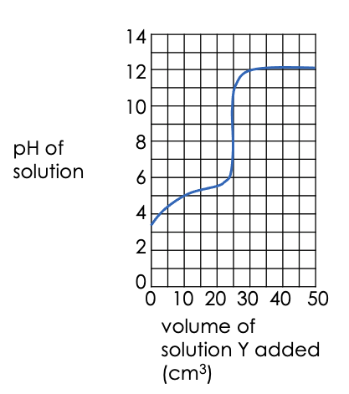
- A student added solution Y to a beaker containing solution X. The graph shows how the pH of the resulting solution changed.

  - What was the pH of solution X before solution Y was added to it?

___________________________________

  - Was solution Y acidic, alkaline or neutral? Explain your answer.
___________________________________
___________________________________
___________________________________
___________________________________
___________________________________

  - What volume of solution Y was needed to completely react with solution X?

____________________________________________________________________________________

- Explain what happens when an acid reacts with an alkali in terms of ions and molecules.

____________________________________________________________________________________
____________________________________________________________________________________
____________________________________________________________________________________
____________________________________________________________________________________
____________________________________________________________________________________
____________________________________________________________________________________

- Complete the word equation for each reaction and write a balanced symbol equation.

- Barium hydroxide + hydrochloric acid →

- Sulfuric acid + sodium hydroxide →

- Lithium hydroxide + nitric acid →

- Calculate the relative formula mass of each of the salts in Q9.

Section C
- Sodium hydroxide reacts with hydrochloric acid.
- What is the alkali in this reaction?
- Write a word equation for this reaction.
- Write a balanced symbol equation for this reaction.
- Write the ionic equation for neutralisation.
- Name the salt produced in this reaction.
- Calculate the relative formula mass of this salt.
- Calculate the percentage by mass of sodium in this salt.
- Compare the physical properties of the elements that make up this salt with the properties of the salt as a compound.
- Identify the type of bonding in this salt.
- Draw a diagram to show how this bonding takes place.

Taking it Further: Acid-Alkali Titration

A student investigates the volume of hydrochloric acid solution that reacts with 25.0 cm³ of sodium hydroxide solution.

- Which piece of equipment could the student use to measure 25.0 cm³ of sodium hydroxide most accurately?
Tick (✓) one box.

Beaker | 
Evaporating basin
Pipette
Test tube

This is the method used:
- Pipette 25.0 cm³ of sodium hydroxide solution into a conical flask.
- Add a few drops of thymol blue indicator to the sodium hydroxide solution.
- Thymol blue is blue in alkali and yellow in acid.
- Add hydrochloric acid solution from a burette until the end-point was reached.

- Explain what would happen at the end-point of this titration. You should mention the acid, the alkali and the indicator in your answer.

____________________________________________________________________________________
____________________________________________________________________________________
____________________________________________________________________________________
____________________________________________________________________________________
____________________________________________________________________________________
____________________________________________________________________________________

- Complete the word equation for the reaction:

Sodium hydroxide + hydrochloric acid ________________________ + ______________

- Explain why a pipette is used to measure the volume of sodium hydroxide solution but a burette is used to measure the volume of hydrochloric acid.

____________________________________________________________________________________
____________________________________________________________________________________
____________________________________________________________________________________
____________________________________________________________________________________

The pipette was labelled as 25.0 ± 0.05 cm³.
- State the resolution of the pipette.

____________________________________________________________________________________

- Calculate the percentage uncertainty in the volume measured using the pipette.
Use the equation:
$$percentage uncertainty= \frac{uncertainty}{volume measured} ×100$$

____________________________________________________________________________________
____________________________________________________________________________________

- The higher the concentration of a sample of hydrochloric acid, the greater the volume of sodium hydroxide will be needed to neutralise the sample of acid.

Describe how titrations could be used to find out which of two samples, X or Y, is a more concentrated acid.

____________________________________________________________________________________
____________________________________________________________________________________
____________________________________________________________________________________
____________________________________________________________________________________
____________________________________________________________________________________
____________________________________________________________________________________
____________________________________________________________________________________
____________________________________________________________________________________
____________________________________________________________________________________
____________________________________________________________________________________

Taking it Further: Titration Calculations
Section A:

- Match each quantity below with the correct units.

Concentration |  | g/dm³
Mass |  | dm³
Volume |  | g
Amount of substance |  | mol
 |  | mol/dm³

- Which of these is the correct definition of concentration?
Tick one box.
The amount of solute per unit volume of solvent
The amount of space a solution takes up
The amount of substance in a solution
- Which is the correct function of an indicator in a titration?
Tick one box.
To measure the concentration of an unknown reactant
To signify the end point of a reaction
To speed up the rate of reaction

- Label the following pieces of apparatus that are involved in a titration.
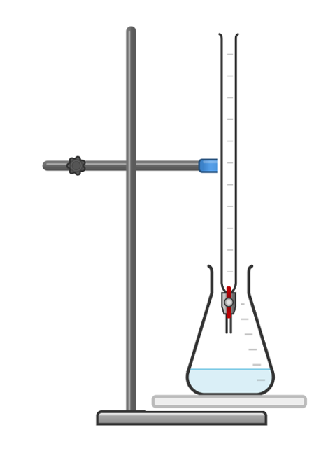

Section B

- A student is investigating the concentration of a sample of sodium hydroxide solution using titration. They use citric acid solution as the acid and phenolphthalein as the indicator.
  - Explain why phenolphthalein is used rather than Universal Indicator.

____________________________________________________________________________________
____________________________________________________________________________________
____________________________________________________________________________________

The equation for the reaction is:

3 NaOH + C₆H₈O₇ C₆H₅O₇Na₃ + 3 H₂O

  - Identify the chemical formula for citric acid.

____________________________________________________________________________________

  - The student required 12.5 cm³ of 0.1 mol/dm³ citric acid to neutralise 20 cm³ of sodium hydroxide solution.
Calculate the concentration of the sodium hydroxide solution in mol/dm³.

____________________________________________________________________________________
____________________________________________________________________________________
____________________________________________________________________________________
____________________________________________________________________________________
____________________________________________________________________________________
____________________________________________________________________________________

  - Explain how the student could make their results more reliable.

____________________________________________________________________________________
____________________________________________________________________________________
____________________________________________________________________________________

- Another student uses a similar method to find the concentration of an unknown citric acid solution using 25 cm³ of sodium hydroxide. The equation for the reaction is:

3 NaOH + C₆H₈O₇ C₆H₅O₇Na₃ + 3 H₂O

The table below shows the student’s results.

Titration | 1 | 2 | 3 | 4 | 5
Volume of citric acid solution (cm³) | 12.50 | 12.15 | 11.75 | 12.10 | 12.10

- State the word used to describe the volume of citric acid.

____________________________________________________________________________________

- 3 of these results are concordant. Explain what is meant by concordant results.

____________________________________________________________________________________
____________________________________________________________________________________
____________________________________________________________________________________

- Use the concordant results to calculate the mean volume of citric acid required. Write your answer to 2 decimal places.

____________________________________________________________________________________
____________________________________________________________________________________
____________________________________________________________________________________

- The concentration of sodium hydroxide was 0.15 mol/dm³. Calculate the concentration of citric acid solution. Write your answer to 2 significant figures.

____________________________________________________________________________________
____________________________________________________________________________________
____________________________________________________________________________________
____________________________________________________________________________________
____________________________________________________________________________________
____________________________________________________________________________________

- A student carried out a titration to determine the concentration of a sulfuric acid sample. They found that 27.1 cm³ of sulfuric acid was needed to neutralise 25 cm³ of 0.1 mol/dm³ of sodium hydroxide.
The equation for the reaction is:

2 NaOH + H₂SO₄ Na₂SO₄ + 2 H₂O

- Calculate the concentration of the sulfuric acid sample.

____________________________________________________________________________________
____________________________________________________________________________________
____________________________________________________________________________________
____________________________________________________________________________________
____________________________________________________________________________________
____________________________________________________________________________________

- Calculate the mass of sodium hydroxide that would have been dissolved to produce 25 cm³ of 0.1 mol/dm³ solution.

____________________________________________________________________________________
____________________________________________________________________________________
____________________________________________________________________________________
____________________________________________________________________________________
____________________________________________________________________________________
____________________________________________________________________________________

Section C
- Scientists can use titration to determine the concentration of sulfuric acid in a sample of rainwater to provide evidence of acid rain.
  - Briefly describe a method that could be used to determine the concentration of sulfuric acid in a rainwater sample.
  - Describe how acid rain is formed.
  - Suggest some environmental impacts of acid rain.
  - One of the main causes of acid rain is the burning of fossil fuels. Explain what fossil fuels are.
  - Suggest why people continue to burn fossil fuels even though they are aware of the environmental consequences.

(HT) Strong and Weak Acids
Section A:
- Which ion do acids produce in aqueous solutions?
Tick one box.
H⁺
OH⁻
H⁻
- Which of these is a strong acid?
Tick one box.
Citric acid
Ethanoic acid
Nitric acid
- Acids react with alkalis. What kind of reaction is this?
Tick one box.
Redox
Combustion
Decomposition
Neutralisation
- A student has a sample of hydrochloric acid. Which is likely to be the pH?
Tick one box.
pH 3
pH 7
pH 10
Section B
- A scientist has a sample of concentrated citric acid.
  - Citric acid is a weak acid. Explain what this means.

____________________________________________________________________________________
____________________________________________________________________________________
____________________________________________________________________________________
  - Explain how an acid can be described as concentrated and weak.

____________________________________________________________________________________
____________________________________________________________________________________
____________________________________________________________________________________

- Hydrogen chloride dissolves in water to form hydrochloric acid. Hydrogen chloride molecules all ionise in water.
Ethanoic acid also dissolves in water. Only a small fraction of ethanoic acid molecules ionise in water.

  - 0.5 g of hydrogen chloride is dissolved in to make 0.5 dm³ of solution.
Calculate the concentration of this solution.
____________________________________________________________________________________
____________________________________________________________________________________
____________________________________________________________________________________

  - Which correctly describes the solution that has been made?
Tick one box.
A concentrated solution of strong acid
A dilute solution of strong acid
A concentrated solution of weak acid
A dilute solution of weak acid

  - Explain how the concentration of the solution could be increased without changing the amount of acid.

____________________________________________________________________________________
____________________________________________________________________________________
____________________________________________________________________________________

  - Which of these solutions would have the lowest pH?
Tick one box.
0.5 mol/dm³ hydrochloric acid solution
0.5 mol/dm³ ethanoic acid solution
2.0 mol/dm³ hydrochloric acid solution
2.0 mol/dm³ ethanoic acid solution

Hydrochloric acid reacts with calcium hydroxide. This reaction can be represented with the following equation.

____ HCl + _____ Ca(OH)₂ ______ CaCl₂ + _____ H₂O

  - Balance this equation.

  - Name the salt produced in this reaction.

____________________________________________________________________________________

  - Calculate the mass of salt made when 84 g of calcium hydroxide reacts with excess acid.

____________________________________________________________________________________
____________________________________________________________________________________
____________________________________________________________________________________

  - This question is for Chemistry only.
Ethanedioic acid (H₂C₂O₄)is a solid that can be dissolved to make a solution. Calculate the mass of ethanedioic acid required to produce 150 cm³ of solution with a concentration of 0.2 mol/dm³.

____________________________________________________________________________________
____________________________________________________________________________________
____________________________________________________________________________________
____________________________________________________________________________________
____________________________________________________________________________________

- Explain the factors that affect the pH of an acid.

____________________________________________________________________________________
____________________________________________________________________________________
____________________________________________________________________________________
____________________________________________________________________________________
____________________________________________________________________________________
____________________________________________________________________________________
____________________________________________________________________________________
____________________________________________________________________________________
____________________________________________________________________________________
____________________________________________________________________________________

Section C

- A scientist has added sulfuric acid to water in a beaker.
  - Is this solution a compound or a mixture? Explain your answer.
  - Describe and explain a method the scientist could use to separate the water from the acid different acid solutions.
  - Is sulfuric acid a strong acid or a weak acid? Explain your answer.
  - State the chemical formula for sulfuric acid.
  - Calculate the relative formula mass for sulfuric acid.
  - Calculate the percentage by mass of hydrogen in sulfuric acid.
  - Is sulfuric acid solution likely to conduct electricity? Explain your answer.

Taking it Further: Volumes of Gases

Section A:
- What are the conditions of rtp?

Tick one box.
Room temperature (22 ºC) and 2 atm of pressure
Room temperature (22ºC) and 1 atm of pressure
Room temperature (20 ºC) and 1 atm of pressure
- What is the molar volume of a gas at rtp?

Tick one box.
20 dm³
22 dm³
24 dm³
- In the box below, write the equation that links number of moles, volume and molar volume.

- State the two factors that must remain constant for 1 mole of two different gases to occupy the same volume.

____________________________________________________________________________________
____________________________________________________________________________________

Section B

Use a periodic table and show all working for the following questions:

- Assuming rtp, calculate the volume of:
- 2 mol of CO₂.
____________________________________________________________________________________
____________________________________________________________________________________

- 0.25 mol of ammonia (NH₃).
____________________________________________________________________________________
____________________________________________________________________________________

- Assuming rtp, calculate the amount of substance present in:.
  - 0.75 dm³ of steam.
____________________________________________________________________________________
____________________________________________________________________________________

  - 200 cm³ of hydrogen.
____________________________________________________________________________________
____________________________________________________________________________________
____________________________________________________________________________________

- A scientist reacts hydrochloric acid with lithium hydroxide.
  - Name the salt that would be formed in this reaction.
___________________________________________________________________________________

  - Write a balanced symbol equation for this reaction.

____________________________________________________________________________________

  - Describe a method that could be used to obtain crystals of the salt produced in this reaction.
____________________________________________________________________________________
____________________________________________________________________________________
____________________________________________________________________________________
____________________________________________________________________________________
____________________________________________________________________________________
____________________________________________________________________________________
____________________________________________________________________________________
____________________________________________________________________________________

  - The scientist then makes zinc chloride by heating zinc in chlorine gas. The equation for the reaction is shown below:

Zn (s)+ Cl₂ (g) ZnCl₂ (s)

Calculate the volume of chlorine needed to react completely with 11 g of zinc.

____________________________________________________________________________________
____________________________________________________________________________________
____________________________________________________________________________________
____________________________________________________________________________________
____________________________________________________________________________________
____________________________________________________________________________________
____________________________________________________________________________________
____________________________________________________________________________________

- Aluminium oxide can be electrolysed according to the following equation:
Al₂O₃ (s) 4 Al (s) + 3 O₂ (s)

  - Calculate the mass of aluminium that would be produced when 800 kg of aluminium is completely electrolysed.

____________________________________________________________________________________
____________________________________________________________________________________
____________________________________________________________________________________
____________________________________________________________________________________
____________________________________________________________________________________

  - Calculate the volume of oxygen that would be produced when 800 kg of aluminium is completely electrolysed.
___________________________________________________________________________________
____________________________________________________________________________________
____________________________________________________________________________________
____________________________________________________________________________________
____________________________________________________________________________________

Section C

- Avogadro’s law states that equal volumes of gases, at the same temperature and pressure, have the same number of molecules.
- State molar volume at rtp.
- Compare the movement of particles in a solid and in a gas.
- Explain what causes gas pressure.
- Describe and explain the relationship between temperature of a gas and pressure.
- Describe and explain the relationship between volume of a gas and pressure.
- 2 dm³ of oxygen gas at 27 Pa of pressure is compressed to a quarter of its original volume. Calculate the pressure at the new volume.

